DEVELOPMENT OF A PROACTIVE DECISION SUPPORT SYSTEM FOR
KNOWLEDGE LOSS RISK ASSESSMENT AND KNOWLEDGE TRANSFER DURING ORGANIZATIONAL TRANSITIONS

Shanuka S. Jayakodi
Bachelor of Science Honours in Management Information Systems
Department of Information Systems
Faculty of Computing
NSBM Green University
Sri Lanka
October 2026

DECLARATION
I declare that the content of this undergraduate thesis titled 'Development of a Proactive Decision Support System for Knowledge Loss Risk Assessment and Knowledge Transfer During Organizational Transitions' is my own work and does not incorporate, without acknowledgement, any material previously submitted for any other degree in any university or institution of higher learning.
Signature: ____________________ Name: Shanuka S. Jayakodi Date: ____________________
Supervisor signature: ____________________ Name: ____________________ Date: ____________________

ACKNOWLEDGEMENT
I sincerely thank my supervisor, the academic staff of the Faculty of Computing, and all participants who contributed expert comparisons and system-evaluation feedback. I am also grateful to my family and colleagues for their encouragement throughout this research.

ABSTRACT
Employee transitions can disrupt important work when specialized knowledge is concentrated in one person and suitable documentation or backup staff are unavailable. This study developed KnowledgeGuard, a web-based decision support prototype for assessing knowledge-loss risk and coordinating knowledge transfer. Following a design science approach, the system assesses expertise uniqueness, documentation gap, project criticality, collaboration dependency, and tenure. It combines an indicator-based score with manager assessment and a supporting machine-learning score. Managers can initiate a structured knowledge-transfer plan for cases classified as high or critical risk.
The prototype was demonstrated using 30 anonymised standalone assessment responses from industry colleagues and a separate generated Q1-Q4 workflow dataset. Ten system evaluators gave a mean System Usability Scale score of 89.50 (SD = 3.07); mean perceived usefulness, ease of use and behavioural intention were 4.43, 4.53 and 4.60. An exploratory aggregation of ten pairwise responses produced a consistent AHP group matrix (CR = 0.0822), but proposed weights different from the predefined baseline. The baseline remained active for all reported scoring demonstrations. These results support prototype functionality and favourable descriptive feedback, not predictive validity or measured reduction of knowledge loss.
KnowledgeGuard demonstrates how risk assessment can be linked to managed knowledge-transfer activities. The generated assessments are not observations from a real organization, and the evaluation does not establish predictive accuracy or lasting knowledge retention. Organizational assessments over time are needed to evaluate those outcomes.

TABLE OF CONTENTS

DECLARATION ii
ACKNOWLEDGEMENT iii
ABSTRACT iv
TABLE OF CONTENTS v
LIST OF FIGURES ix
LIST OF TABLES x
LIST OF ABBREVIATIONS xii
1. INTRODUCTION 1
1.1 Chapter overview 1
1.2 Background 1
1.3 Problem statement 2
1.4 Research gap 2
1.5 Research questions 3
1.6 Research motivation and significance 3
1.7 Scope 4
1.8 Overview of the proposed solution 5
1.9 Chapter summary 7
2. OBJECTIVES 8
2.1 General objective or aim 8
2.2 Specific objectives 8
2.3 How the objectives guide the thesis 9
2.4 Chapter summary 9
3 LITERATURE REVIEW 10
3.1 Chapter overview 10
3.2 Domain concepts and theories 10
3.2.1 Organizational knowledge, tacit knowledge and knowledge-loss risk 12
3.3 Existing studies, systems or frameworks 12
3.3.1 Repositories versus proactive decision support 12
3.3.2 Limitations of self-reported assessment data 13
3.3.3 The gap between risk identification and mitigation 13
3.3.4 Comparison with related systems and frameworks 14
3.4 Technical approaches 15
3.4.1 Operationalization of knowledge-loss indicators 15
3.4.2 Transparent weighted scoring and AHP 16
3.4.3 Supporting machine learning and anomaly review 17
3.4.4 Generative AI and knowledge-transfer planning 17
3.4.5 Design-science evaluation, SUS and TAM 18
3.5 Research gap and implications for this work 18
3.6 Chapter summary 19
4. METHODOLOGY 20
4.1 Research design 20
4.2 Data, participants and stakeholders 20
4.3 Requirements and analysis 22
4.4 Proposed design 24
4.4.1 Components and data flow 24
4.4.2 From survey answer to indicator 30
4.4.3 Combining the three scores 32
4.4.4 From risk review to knowledge transfer 36
4.5 Development and implementation procedure 38
4.6 Evaluation plan 38
4.7 Ethics and project management 41
4.8 Chapter summary 42
5. RESULTS 43
5.1 Chapter overview 43
5.2 Final data and evaluation setting 43
5.3 Developed artefact and analytical outputs 44
5.3.1 Simulated knowledge-transfer trace 46
5.4 Functional and implementation evidence 47
5.5 Evaluation results 49
5.6 Results by objective 51
5.7 Chapter summary 52
6. DISCUSSION AND CONCLUSIONS 53
6.1 Discussion of key findings 53
6.1.1 Answers to the research questions 53
6.2 Comparison with literature 54
6.3 Contribution and practical implications 54
6.4 Limitations 55
6.5 Future work 56
6.6 Conclusions 57
REFERENCES 58
APPENDICES 61
Appendix A: Assessment questionnaire and indicator mapping 62
Appendix B: AHP expert-comparison instrument and calculation 64
Appendix C: System Usability Scale and Technology Acceptance Model instruments 65
Appendix D: Functional test scenarios and evidence 66
Appendix E: System demonstration protocol and supplementary interface evidence 68
Appendix F: Participant information consent and data handling 70
Appendix G: Reproducibility and evidence manifest 71

LIST OF FIGURES
Figure 1.1: Overview of the proposed KnowledgeGuard workflow
Figure 3.1: Conceptual map of the literature informing KnowledgeGuard
Figure 4.1: KnowledgeGuard architecture and principal data flows
Figure 4.2: Class diagram and principal data relationships in KnowledgeGuard.
Figure 4.3: Use-case diagram for role-based KnowledgeGuard interactions
Figure 4.4: Activity diagram for assessment, validation and knowledge transfer
Figure 4.5: Supporting machine-learning score process
Figure 4.6: Sequence diagram for risk assessment and manager validation
Figure 4.7: Sequence diagram for knowledge-transfer plan completion and sign-off
Figure 5.1: Preliminary assessment before manager validation
Figure 5.2: Manager-validated assessment outcome
Figure 5.3: Knowledge-transfer plan creation and backup safeguards
Figure 5.4: Five-stage knowledge-transfer plan execution
Figure 5.5: Corrected AHP group result and unchanged live baseline
Figure 5.6: Quarterly score history from the generated workflow dataset
Figure 5.7: Aggregate System Usability Scale result
Figure 5.8: Technology Acceptance Model construct means

LIST OF TABLES
Table 1.1
Table 2.1
Table 3.1
Table 3.2
Table 4.1
Table 4.2
Table 4.3
Table 4.4
Table 4.5
Table 4.6
Table 4.7
Table 4.8
Table 5.1
Table 5.2
Table 5.3
Table 5.4
Table 5.5
Table 5.6
Table 5.7
Table A.1
Table B.1
Table B.2
Table C.1
Table E.1
Table G.1

LIST OF ABBREVIATIONS
AHP Analytic Hierarchy Process
API Application Programming Interface
CI Consistency Index
CR Consistency Ratio
CSV Comma-Separated Values
DSS Decision Support System
EU Expertise Uniqueness
DG Documentation Gap
PC Project Criticality
CD Collaboration Dependency
KT Knowledge Transfer
ML Machine Learning
SUS System Usability Scale
T Tenure
TAM Technology Acceptance Model

1. INTRODUCTION

1.1 Chapter overview
This chapter introduces the problem of knowledge loss during employee transitions and explains why an assessment linked to knowledge-transfer action is needed. It presents the problem, research gap, questions, significance, scope, and proposed solution.

1.2 Background
Organizations depend on knowledge held in documents, systems, work routines, and employees’ experience. Some knowledge can be recorded as instructions. Other knowledge develops through practice and judgement and may be difficult to express fully in a document. The distinction between explicit and tacit knowledge helps explain why access to documentation does not always enable another employee to perform a specialist’s work [1].
Resignation, retirement, role change, or extended absence can create a continuity risk. Its importance depends on the knowledge involved, the available documentation, the work supported by the employee, and whether another person can take over the relevant tasks. Organizational knowledge transfer requires knowledge to become usable by other people, beyond merely storing information [2].
A systematic review of 74 studies distinguished knowledge-loss drivers, effects, and mitigation, finding that much published work addresses losses already under way [3]. Recent case studies also link disruption to weak sharing of personal knowledge and show that job shadowing can form part of retention practice [4]. These findings justify looking for exposed work before a transition and specifying who will receive and practise the knowledge; they do not establish the prevalence of this problem in the demonstration dataset.
KnowledgeGuard is a decision support prototype designed to identify cases requiring attention, present assessment information for manager review, and coordinate action involving a knowledge holder and a backup employee. Its risk score summarizes defined indicators. It does not directly measure the probability of departure or actual future knowledge loss.

1.3 Problem statement
Organizations may struggle to identify which employee transitions require urgent knowledge-transfer preparation. Relevant information can be spread across employees, managers, documents, and operational processes. A manager may know that an employee is important yet lack a consistent way to assess why the employee’s absence would cause difficulty or whether a backup is ready.
Specialized expertise may be concentrated in one person while instructions remain incomplete. Project importance, dependency, and replaceability can vary independently. An assessment must therefore consider more than tenure or departure status. Automated scoring can apply the same rules across cases, but a manager may know circumstances absent from recorded responses. Identifying a risk is also only the start: a response requires transfer activities and an assessment of backup competence.
Research on knowledge loss identifies workforce transitions, limited knowledge sharing, and inadequate retention practices as sources of organizational exposure [3], [4]. These findings support the need for a structured assessment linked to transfer preparation.
The central problem is how a decision support system can help identify employee-level knowledge-loss risk and support structured knowledge-transfer decisions during organizational transitions.

1.4 Research gap
Existing research explains knowledge-loss risks and identifies retention practices, including documentation, knowledge sharing, and job shadowing [3], [4], [6]. However, these findings do not by themselves demonstrate how an employee-level assessment can be connected to manager review, assigned transfer activities, and documented backup competence within one evaluated application. This study investigates that integration through the KnowledgeGuard prototype.
The study addresses this design and integration opportunity. It does not claim to invent a theory of knowledge transfer or establish that no existing product has similar functions. Its contribution is the design, implementation, and limited evaluation of KnowledgeGuard as a particular response to the defined problem.
In design science, a working artefact and its evaluation need to be described clearly [5]. Here the artefact is the implemented assessment-to-transfer workflow; the design insight concerns how to link explainable indicators, review, and assigned transfer tasks under explicit evidence limits.
The gap is practical and evaluative as well as technical. Research identifies useful transfer mechanisms but shows that sector and work context shape retention [6]; a generic score therefore needs local testing. This project tests whether the activities can be joined into a traceable prototype, while leaving outcome validation for a future organizational study.

1.5 Research questions
The main research question is: How can a decision support system help identify employee-level knowledge-loss risk and support structured knowledge-transfer decisions during organizational transitions?
- RQ1. How can literature-informed indicators of employee-level knowledge-loss risk be operationalized in a structured prototype assessment?
- RQ2. How can indicator-based assessment, manager judgement, and supporting machine-learning analysis be integrated into a decision support workflow?
- RQ3. How can the system support the planning, completion, and review of knowledge-transfer activities after a high-risk case is identified?
- RQ4. How usable and acceptable is the prototype to its evaluators, and which aspects of its intended workflow can be demonstrated through testing?

1.6 Research motivation and significance
The practical motivation is to help managers identify important knowledge dependencies before a transition disrupts work. A structured assessment can make the reasons for prioritization visible; a linked transfer plan can direct attention to documentation, observation, discussion, and practice. The system remains a support for human judgement rather than an autonomous employment decision.
The research significance lies in examining whether established methods can be connected into one auditable workflow. Design science research supports building and evaluating an information-system artefact in response to a practical problem [5]. The value demonstrated in this study concerns the prototype and its evaluated functions; it is not evidence of long-term organizational impact.

1.7 Scope
KnowledgeGuard assesses employee-level knowledge-loss risk using five indicators: expertise uniqueness, documentation gap, project criticality, collaboration dependency, and tenure. These dimensions define the study boundary; their theoretical basis and measurement are explained in Chapters 3 and 4. The prototype combines an indicator-based score, manager judgement, and a supporting machine-learning score. It supports knowledge-transfer planning for employees classified as high or critical risk, including assigned activities, knowledge-holder and backup confirmations, managerial approval, and review through a later separately imported assessment.
The study covers prototype development and evaluation using 30 anonymised standalone industry-colleague assessments, a separate generated Q1-Q4 workflow dataset, ten pairwise-comparison responses and ten system-evaluation responses. The prototype was deployed online for evaluator access, not a partner-organization field study. AHP provided an exploratory comparison with the predefined weights; it did not change the scoring configuration used in the evaluation.
The colleague responses do not constitute a representative organizational sample, and the generated Q1-Q4 dataset does not represent observations of real employees over four quarters. Online deployment provided access for evaluation but did not constitute a partner-organization field study. The evaluation therefore addresses prototype functionality, usability, and perceived acceptance; it does not establish independent real-world predictive accuracy, lasting knowledge retention, or an actual reduction in organizational knowledge loss. Risk classifications support managerial review and knowledge-transfer prioritization. Further organizational evaluation would be required to assess sustained transfer outcomes.

Table 1.1: Scope and evidence boundaries
Included in this study | Outside the demonstrated evidence
Prototype assessment and manager-reviewed KT workflow | Deployment or observed outcomes in a partner organization
Standalone colleague responses and a separate generated Q1-Q4 test dataset | A real four-quarter cohort or observed retention over time
Collected expert comparisons and usability responses | Validated indicator weights or population-wide acceptance
Scoring and functional demonstration | Independent prediction of departures or knowledge loss

1.8 Overview of the proposed solution
The workflow begins with structured assessment responses, which are processed into indicator scores and risk information for managerial review. A case needing attention may lead to a plan involving the knowledge holder, backup, and manager. The plan organizes documentation, shadowing, a structured interview, backup competence assessment, and final sign-off. Later assessments can support review of changes in calculated risk. Figure 1.1 summarizes the assessment, managerial review, knowledge-transfer, and reassessment workflow.
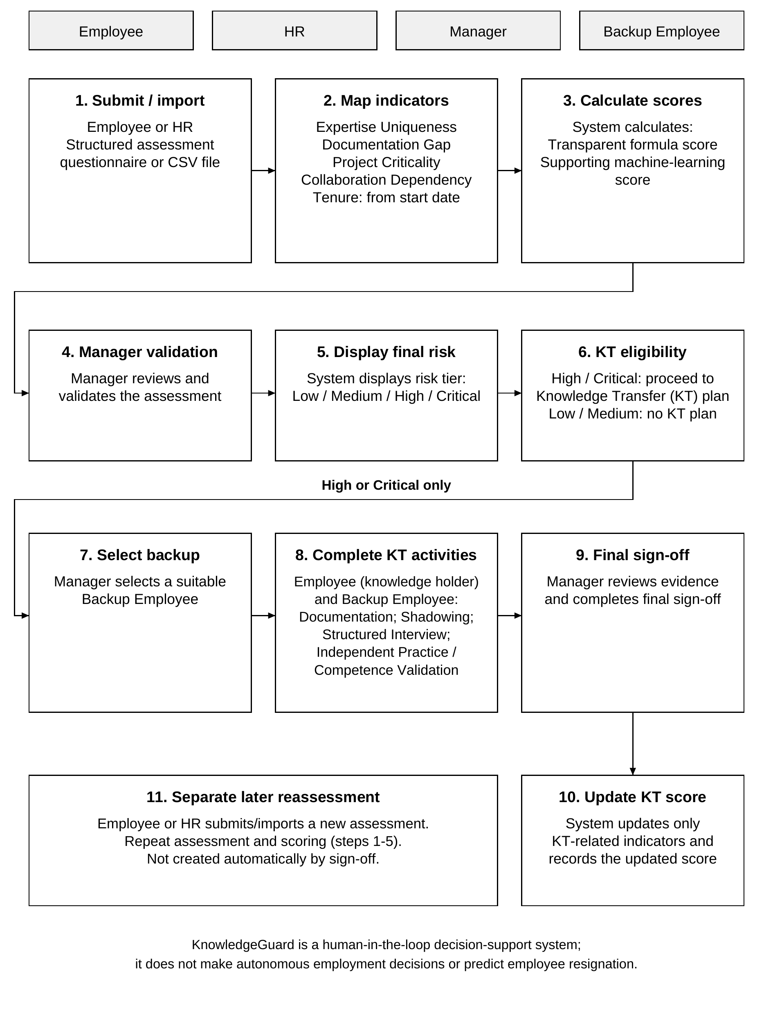
Figure 1.1: Overview of the proposed KnowledgeGuard workflow.

1.9 Chapter summary
This chapter defined the knowledge-loss problem, the study’s design contribution, four research questions, and the boundaries of the prototype evaluation. Chapter 2 states the objectives, and Chapter 3 reviews the research informing the assessment and transfer workflow.

2. OBJECTIVES

2.1 General objective or aim
The general objective of this study was to design, develop, and evaluate KnowledgeGuard, a decision support prototype that assesses employee-level knowledge-loss risk during organizational transitions and supports structured knowledge-transfer decisions.
The intended contribution was an accountable decision-support workflow rather than an autonomous personnel-decision tool. KnowledgeGuard was therefore designed to make its assessment inputs and risk information visible to a manager, link eligible cases to knowledge-transfer activities, and retain a record of review and approval. The evaluation asks whether this prototype workflow can be implemented and demonstrated within the available evidence setting; it does not claim to establish that the system predicts employee departure or eliminates organizational knowledge loss.

2.2 Specific objectives
- Objective 1. To identify and define measurable indicators of knowledge-loss risk and develop a structured assessment method that checks the quality of assessment responses.
- Objective 2. To examine relevant knowledge-management, risk-assessment, and decision-support research and use it to inform the design of the prototype.
- Objective 3. To design and implement an integrated workflow that combines indicator-based scoring, manager assessment, supporting machine-learning analysis, risk classification, and knowledge-transfer planning and review.
- Objective 4. To evaluate the prototype’s assessment and knowledge-transfer functions through testing, and to assess perceived usability and acceptance using system-evaluation responses.

Table 2.1: Objective-to-evidence alignment
Objective | Method | Evidence reported in Chapter 5
O1 Indicators and assessment | Define five indicators; map survey items; apply response-quality checks; demonstrate AHP configuration safeguard | Indicator mapping, calculated scores, response-quality flags and configuration-control evidence
O2 Literature and design basis | Review knowledge-loss evidence and related systems | Synthesis and justified design choices
O3 Integrated prototype | Implement scoring, validation and five KT stages | System outputs and functional scenarios
O4 Evaluation | Run tests; calculate SUS and acceptance summaries | Recorded test outcomes and questionnaire summaries

2.3 How the objectives guide the thesis
The objectives provide the thread that links the thesis chapters. Chapter 3 supplies the research basis for the indicators, analytical methods and transfer workflow. Chapter 4 explains how the prototype and evaluation were designed. Chapter 5 reports the evidence available for each objective, and Chapter 6 interprets how far that evidence answers the research questions. This alignment prevents a feature from being treated as a research contribution unless it is supported by a stated method and result.

2.4 Chapter summary
This chapter defined the aim and four specific objectives of the study and linked each objective to its method and expected evidence. Chapter 3 reviews the concepts, prior systems and technical approaches that provide the rationale for the prototype design.

3. LITERATURE REVIEW

3.1 Chapter overview
This chapter reviews the literature and concepts that inform KnowledgeGuard, a decision-support prototype for identifying employee-level knowledge-loss risk and supporting knowledge-transfer planning. The review begins with organizational knowledge, tacit knowledge, and the risks created when important knowledge is concentrated in individual employees. It then examines the limitations of existing knowledge-management approaches, particularly document repositories, self-reported assessments, and approaches that identify risk without supporting follow-up transfer activities.
The chapter next explains the design basis for KnowledgeGuard: the five risk indicators, transparent weighted scoring, Analytic Hierarchy Process (AHP), response-quality checks, supporting machine learning, generative AI assistance, and knowledge-transfer activities. Finally, it synthesizes the literature to define the research gap addressed by the prototype.

3.2 Domain concepts and theories
The reviewed literature follows a progression from the broad problem of organizational knowledge to the specific decision-support workflow implemented in KnowledgeGuard. Organizational knowledge establishes the domain; tacit knowledge explains why documentation alone may be insufficient; employee transitions create potential exposure; and the identified limitations justify an integrated assessment-to-transfer workflow.
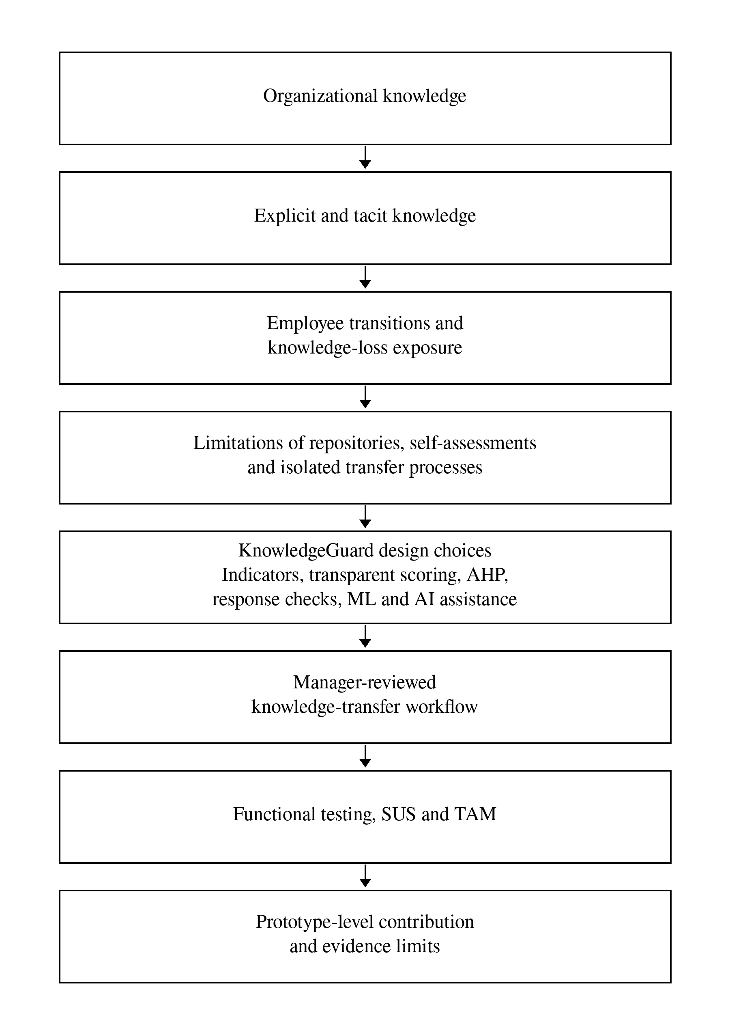
Figure 3.1: Conceptual map of the literature informing KnowledgeGuard.

3.2.1 Organizational knowledge, tacit knowledge and knowledge-loss risk
Organizational knowledge includes documented information, work routines, practical experience, technical skills, judgement, and contextual understanding used to perform work. Knowledge management concerns the creation, capture, sharing, retention, and application of this knowledge.
A central distinction is between explicit and tacit knowledge. Explicit knowledge can be documented and communicated through manuals, procedures, reports, system records, and policies. Tacit knowledge is more closely connected to personal experience, judgement, practical skill, and context [1]. An organization may retain documents after an employee leaves but still lose the ability to solve unusual problems, understand historical decisions, or perform work efficiently.
Employee transitions such as resignation, retirement, internal transfer, promotion, restructuring, or extended absence can create knowledge-loss exposure. The risk may be greater when specialized expertise is concentrated in one person, documentation is incomplete, critical work depends on that person, or colleagues frequently rely on them for support [3], [4], [7]. KnowledgeGuard treats knowledge loss as a proactive assessment and decision-support problem. It does not predict whether an employee will resign; it identifies cases where an absence could create difficulty and where transfer preparation may be appropriate.
A high risk score is not evidence that knowledge has already been lost. It is an indication that the case should be reviewed. Similarly, a completed transfer plan records workflow completion but does not independently prove that a backup employee will retain and apply the knowledge over time.

3.3 Existing studies, systems or frameworks

3.3.1 Repositories versus proactive decision support
Knowledge repositories and collaboration systems, such as SharePoint and Confluence, are valuable for storing documents, sharing information, and maintaining recorded knowledge [12], [13]. ServiceNow Knowledge Management also supports controlled publication and approval of knowledge articles [14]. However, repositories primarily manage knowledge that has already been captured. They do not inherently identify which employee has difficult-to-replace knowledge, determine the operational consequences of that employee's absence, or initiate a knowledge-transfer workflow from a risk assessment.
This does not mean that repository systems are ineffective. They can support KnowledgeGuard by storing documentation created during transfer activities. The limitation is that document storage alone does not provide proactive employee-level risk assessment or confirm that a backup employee can perform the relevant work.

3.3.2 Limitations of self-reported assessment data
Structured assessments, spreadsheets, and survey platforms can collect useful employee-level information. However, self-reported answers may contain response-quality issues, such as limited variation, inconsistent interpretation, or potentially self-enhancing answers. Ward and Meade recommend prevention, screening, and transparent reporting when handling potentially careless survey responses [17].
A straight-lined or contradictory response does not prove dishonesty. It may reflect rushed completion, misunderstanding, unusual work circumstances, or limited differentiation between questions. KnowledgeGuard therefore displays response-quality flags for manager review rather than labelling an employee as dishonest. The prototype uses local rule-based checks for potentially rushed, contradictory, or self-enhancing answer patterns; these checks are not a validated lie-detection method.

3.3.3 The gap between risk identification and mitigation
A risk score alone does not transfer knowledge. Once a potentially high-risk case is identified, a manager must still determine what knowledge requires transfer, who is a suitable backup employee, which activities should be completed, and whether the backup has practised the work.
Research on knowledge transfer supports documentation, observation, interaction, practice, and recipient involvement rather than relying only on static documents [2], [18], [19]. KnowledgeGuard therefore links assessment to a manager-reviewed knowledge-transfer workflow: assessment, risk information, manager review, KT planning, documentation, shadowing, interview, practice, sign-off, and later reassessment.

3.3.4 Comparison with related systems and frameworks
Table 3.1 compares selected systems and frameworks with the specific problem addressed by KnowledgeGuard. This is not a hands-on product benchmark. It compares documented or implemented functions only.

Table 3.1: Related systems and frameworks compared with KnowledgeGuard
Example | Main documented focus | Relationship to KnowledgeGuard
SharePoint | Collaborative file storage and versioning | May store KT documents; no employee risk-assessment workflow evaluated
Confluence | Shared pages, attachments, and team knowledge | May store KT notes and process knowledge; no product test conducted
ServiceNow Knowledge Management | Knowledge-article governance and approval | Related approval capability; different assessed object
APQC Knowledge Loss Risk Matrix | Prioritizing knowledge areas exposed to loss | Comparable prioritization concept; detailed matrix not publicly available
SAP SuccessFactors | Successor identification and readiness | Related continuity and backup planning; product not tested
KnowledgeGuard | Employee-level assessment, manager review, KT tasks, backup practice, and sign-off | Integrated prototype workflow; organizational impact remains unvalidated

The reviewed systems may be configured or combined differently by organizations. KnowledgeGuard does not claim that no other system can provide similar functionality. Its contribution is the implementation and limited evaluation of one focused assessment-to-transfer workflow.

3.4 Technical approaches

3.4.1 Operationalization of knowledge-loss indicators
KnowledgeGuard uses five indicators to represent different dimensions of employee-level knowledge-loss exposure: expertise uniqueness, documentation gap, project criticality, collaboration dependency, and tenure. The first four indicators are derived from structured assessment responses, while tenure is calculated using the employee's recorded start date. The literature supports examining these dimensions, but it does not establish this exact five-indicator model or its fixed percentages as universally valid [1], [2], [9], [10], [11]. Tenure is given lower importance because long service provides context but does not prove irreplaceable or critical knowledge.
Table 3.2 makes the selection logic explicit. The indicators were chosen through synthesis of related evidence rather than adoption of a single validated five-factor instrument. Each indicator represents a different question that a manager may need to consider when deciding whether transfer preparation is warranted. Keeping the indicators separate also helps the system explain why a case requires review and which parts of the exposure a transfer activity can plausibly address.

Table 3.2: Literature basis for the KnowledgeGuard indicators
Indicator | Research rationale | Design implication in KnowledgeGuard
Expertise uniqueness | Knowledge concentrated in one person can be difficult to replace [9], [10] | Assess whether alternative holders can perform comparable work
Documentation gap | Tacit or inaccessible knowledge is difficult for another employee to use [1], [2] | Assess whether essential procedures and context are available in usable form
Project criticality | The consequence of loss depends on the work and services affected [4], [11] | Assess the potential disruption associated with important work
Collaboration dependency | Knowledge transfer and work continuity depend on relationships and reliance on people [2], [3] | Assess how strongly colleagues depend on the holder for support or decisions
Tenure | Length of service may provide context about accumulated experience but does not prove unique expertise [8] | Calculate contextual service-length information with a lower initial weight

The table does not claim that the five factors are exhaustive or universally sufficient. For example, an organization may later need to consider regulatory exposure, customer relationships, role scarcity, succession readiness, or transition likelihood. Those contextual matters can inform manager review and future organization-specific calibration, but they were not added to the baseline formula because the prototype required a small, explainable, consistently available set of inputs.
There is also an important distinction between selection of an indicator and validation of its numerical measurement. Literature can justify considering documentation gap or collaboration dependency, but it cannot automatically validate the exact questionnaire wording, score mapping, thresholds, or relative weight used in this prototype. Chapter 4 therefore describes these operational choices explicitly, while Chapter 5 reports only the evidence available for their implementation and evaluation.

3.4.2 Transparent weighted scoring and AHP
A transparent weighted score was selected because managers should be able to understand why a case receives a particular risk tier. KnowledgeGuard begins with researcher-defined baseline weights and combines the resulting formula score with manager validation and a supporting ML score. The baseline weights are design assumptions rather than universal facts; their exact allocation and the full scoring formula are specified in Chapter 4. Manager assessment has the greatest influence in the validated result because contextual work information may not be fully represented in survey responses.
AHP provides a structured method for proposing indicator weights through pairwise comparisons and a consistency ratio (CR) that assesses coherence [20]. KnowledgeGuard uses AHP as optional calibration, not as a per-employee calculation. This study compares an aggregated expert-response matrix with the predefined baseline but does not apply its proposed weights. CR below 0.10 indicates acceptable group-matrix consistency; it does not establish that every respondent was consistent or that the weights predict organizational outcomes.

3.4.3 Supporting machine learning and anomaly review
KnowledgeGuard uses a Random Forest classifier as a supporting machine-learning component. Random Forest combines multiple decision trees to classify structured data [21]. The ML service receives the five indicator values and returns a supporting risk tier and score; it cannot make an autonomous employment decision.
The default model uses synthetic profiles whose risk-tier labels are derived from the baseline formula. Its metrics therefore demonstrate reproduction of configured scoring patterns, not independent prediction of employee departure, service disruption, or knowledge loss. The system can be retrained using real manager-validated records when sufficient data are available, but independent organizational outcome labels would still be necessary to establish predictive validity.
Isolation Forest identifies observations that are relatively unusual within a dataset [22]. In KnowledgeGuard, it flags unusual patterns in an employee's risk-score history when sufficient history exists. An alert prompts review; it does not establish the cause of the change or show that an employee gave false answers.

3.4.4 Generative AI and knowledge-transfer planning
KnowledgeGuard uses an external generative-AI service for plain-language risk explanations, KT interview questions, improvement suggestions and manager questions about team risk [23]. In the implemented chat interface, the service may also return a proposed KT plan or assessment validation. The manager sees the proposed action and must select an execution button; the application's ordinary authorization and eligibility routes then process the request. Generated responses can be wrong or incomplete, so they require review. These functions support discussion and workflow rather than independent evidence that risk has decreased.
The knowledge-transfer workflow supports documentation, shadowing, a structured interview, backup practice and competence assessment, then final manager sign-off. Knowledge tags help rank potential backup candidates with shared knowledge; this is a recommendation aid, not proof of suitability. The backend also prevents selection of a backup already classified as high or critical risk. Completed work may update only indicators that the activities can plausibly mitigate; a later separately imported assessment is needed to review calculated risk.

3.4.5 Design-science evaluation, SUS and TAM
Design Science Research supports development and evaluation of an information-system artefact intended to address a practical problem [5]. Functional testing evaluates whether KnowledgeGuard performs required actions, such as importing assessments, calculating scores, showing review flags, applying AHP consistency safeguards to submitted matrices, restricting unsuitable backups, and recording KT progress.
The System Usability Scale (SUS) measures perceived usability [24]. The Technology Acceptance Model (TAM) examines perceived usefulness, perceived ease of use, and behavioural intention [25]. Together, functional tests, SUS, and TAM provide prototype-level evidence; they do not establish organization-wide acceptance, real-world predictive accuracy, or lasting knowledge retention.

3.5 Research gap and implications for this work
The literature shows that organizations may lose valuable knowledge when tacit or specialized expertise is concentrated in individual employees [1], [3], [9]. It also shows that documentation alone may be insufficient, because recipients may need observation, discussion, and practice before they can perform work independently [2], [18], [19].
Existing repositories, assessment tools, and succession approaches address useful parts of the broader problem. However, the reviewed work does not by itself demonstrate an evaluated workflow that connects employee-level assessment, transparent indicator-based scoring, response-quality review, manager validation, supporting ML analysis, AI-assisted planning, backup participation, competence assessment, sign-off, and later reassessment.
The research gap is therefore an integration and evaluation opportunity, not a claim that no similar technology exists. KnowledgeGuard addresses it by implementing these components in one web-based, manager-reviewed decision-support prototype. Its contribution is not a new ML algorithm, universal indicator weights, or proof of organizational knowledge retention. It is the design, implementation, and limited evaluation of an integrated workflow.

3.6 Chapter summary
This chapter reviewed the concepts and literature informing KnowledgeGuard. It explained why employee transitions can create knowledge-loss exposure, why repositories and risk scores alone are insufficient, and why a manager-reviewed transfer workflow is required.
The chapter justified the selected indicators, transparent scoring, AHP, response-quality review, Random Forest, Isolation Forest, generative-AI assistance, and KT stages. It also clarified that response flags do not detect lies, ML provides support rather than autonomous decisions, and workflow completion does not prove long-term knowledge retention. Chapter 4 explains how the system was designed, implemented, and evaluated.

4. METHODOLOGY

4.1 Research design
This study used design science research to develop and evaluate a decision support artefact addressing a defined organizational problem [5]. The unit of design was KnowledgeGuard: an application that turns assessment responses into reviewable risk information and links selected cases to knowledge-transfer activities. The work followed problem identification, review of relevant research, requirements definition, construction, and evaluation. Iterative changes to the interface and processing logic were made during development. This method is appropriate because the research question concerns how a working system can support an assessment and response workflow, rather than testing a general causal theory of employee turnover.
Functional tests check whether the implemented workflow follows its rules; questionnaire responses describe perceived usability. Neither shows that knowledge was retained following an actual employee transition. Generated assessments therefore demonstrate operation, not field effectiveness.

4.2 Data, participants and stakeholders
Four separate evidence sources were used. First, 30 anonymised standalone Q1 assessment responses were collected from colleagues employed in industry. Each response contained ten questionnaire items covering backup coverage, difficulty of transferring work, documentation, work criticality and dependency, with direct and reverse-worded items. These convenience responses were used to demonstrate mapping to four survey-derived indicators. Each colleague manually supplied an employment start date for the prototype tenure calculation. The responses were not supplied by a partner organization and are not a representative employee cohort.
Second, a separate generated dataset contains 30 fictional employee identities in each of Q1, Q2, Q3 and Q4: 120 generated assessment rows in total. The same fictional identities link the four test quarters for import and history demonstrations. None is linked to the 30 real colleague responses. These controlled scenarios test score history, manager validation and KT workflow; they are not observed employee follow-up.
Third, ten working professionals with HR, management, technical or organizational-process experience used the deployed prototype and completed SUS and acceptance items; exact role counts and affiliations were not recorded. Fourth, saved synthetic ML metrics provide implementation evidence. Separately, ten pairwise-comparison responses were collected for exploratory AHP analysis. The corrected importer converts the form's 1-left, 5-equal, 9-right scale to reciprocal ratios before taking geometric means across responses. This comparison was not used to replace the baseline weights during evaluation.
Table 4.1: Data sources and permitted interpretation
Source | Quantity or period | Purpose and status
Standalone colleague assessment CSV and manually supplied start dates | 30 anonymised colleague responses | Real prototype input for mapping, scores and tenure calculation
Separate quarterly test scenarios | Q1-Q4 | Controlled test sequence for workflow demonstration; separate from colleague responses
System-evaluation forms | 10 collected responses | Descriptive SUS and acceptance ratings
Synthetic ML training records and saved metrics | 500 generated training profiles | Supporting ML implementation evidence; not real-world prediction validation

The application stakeholders are employees providing assessments, managers reviewing risk and transfer, HR users inspecting authorized results, and backup employees participating in transfer. These roles are distinct from research respondents. The study reports aggregate questionnaire results and uses generated identities for workflow screenshots.
Table 4.2: Stakeholders and their role in the workflow
Actor | Main responsibility | Evidence or decision
Employee | Provide assessment answers and knowledge resources | Mapped responses and task submissions
Manager | Validate risk and assess backup competence | Validated scores, approvals and sign-off
Backup employee | Observe, discuss and practise the work | Confirmations and practice evidence
HR or research user | Import responses and review risk information | Assessment records and dashboard summaries

4.3 Requirements and analysis
Requirements were drawn from the practical risk-and-response problem, literature reviewed in Chapter 3, and the available project specification and implementation. The assessment needed to accept a structured CSV, map responses to four survey-based indicators, derive tenure from a stored start date, expose response-quality warnings, and retain a traceable score and tier. Because manager context is absent from the survey, the system also needed a recorded validation step. A further requirement was to protect the scoring configuration against inconsistent expert comparisons. The supplied implementation checks the submitted matrix again in the API before changing the configured weights.
KT planning requires a High or Critical holder, an eligible backup, task evidence and confirmations, competence review, and manager sign-off before recalculation. The interface uses knowledge-tag overlap to suggest backups and knowledge areas; overlap is guidance, not proof of suitability. The backend checks distinct employee accounts, the manager's team boundary, and the backup's risk tier. It rejects a High or Critical backup even if the interface is bypassed. An unscored backup is not automatically classified as high risk, which limits this safeguard.
Each requirement has a corresponding observation for evaluation: a recognized CSV should produce mapped indicators; the AHP interface should disable application of inconsistent judgements; an ineligible holder or high-risk backup should be rejected; and an unfinished KT task should prevent sign-off. The direct API route must also be tested with an inconsistent matrix to confirm its rejection response and unchanged settings. The user roles and permitted actions identify where authorization checks matter. Screenshots can illustrate a state, but the result should be supported by a recorded input, expected outcome, and observed system response.
Nonfunctional priorities included access by role, legible reasons for a score, graceful handling of an unavailable ML service, and records that permit a manager to inspect progress. These are design requirements; Chapter 5 reports what was actually tested. The extensive original use cases, detailed screen flows, and test-case scripts belong in appendices when needed. The following sections give the implemented design and the evaluation methods needed to interpret its results.
Table 4.3: Functional requirements and observable checks
Requirement | Intended behaviour | Proposed check
FR01 Assessment import | Map CSV answers to four indicators; derive tenure | Inspect mapped row and formula
FR02 Manager review | Record validated input and combine three scores | Recalculate a known example
FR03 Weight control | Reject inconsistent comparisons in UI and API | Check disabled Apply action and API 400; confirm settings unchanged
FR04 KT eligibility | Allow high or critical holder and viable backup | Try eligible and ineligible cases
FR05 KT completion | Require evidence, confirmations and competence review | Attempt premature sign-off
FR06 Service resilience | Retain scoring when ML request fails | Simulate service unavailability
FR07 Manager assistance | Show manager-scoped team risk answers and proposed actions requiring confirmation | Inspect manager chat, confirmation controls and backend role checks
FR08 Notifications | Show in-app workflow alerts; send email when configured | Inspect alert triggers and email service; record delivery only if observed

A representative use case begins when an authorized user imports a questionnaire CSV, checks mapping and quality warnings, and opens an employee’s score for a manager. After validation, an eligible case permits nomination of a backup and creation of a KT plan. The expert submits resources and joins shadowing and interview activities; the backup demonstrates the task; the manager checks the evidence and closes the plan. A separate import is required to create a later-quarter assessment. This order distinguishes assessment, intervention, and reassessment and guides the test scenarios in Section 4.6.

4.3.1 Non-functional requirements
Non-functional priorities were role-based access, visible scoring rules, continued formula scoring when ML is unavailable, usable manager review, and maintainable separation of the interface, application server, database and ML service. The evaluation used anonymised or generated inputs. The chatbot sends current team summaries to an external AI provider, and email delivery can include an employee name and risk tier. Organizational use would therefore require approved data sharing, access controls and retention rules. No penetration, load or organizational privacy audit was completed.

4.4 Proposed design

4.4.1 Components and data flow
KnowledgeGuard comprises a React/Vite interface, a Node.js/Express application layer, MongoDB accessed through Mongoose, and a separate Python/FastAPI service. The backend coordinates imports, authentication and role checks, scoring, KT tasks, and communication with the ML and generative-AI services. This separation allows the assessment workflow to remain under application control even when a supporting service is unavailable. Assessment, risk-score, employee, KT-plan, and KT-task records connect an imported response with later review and action.
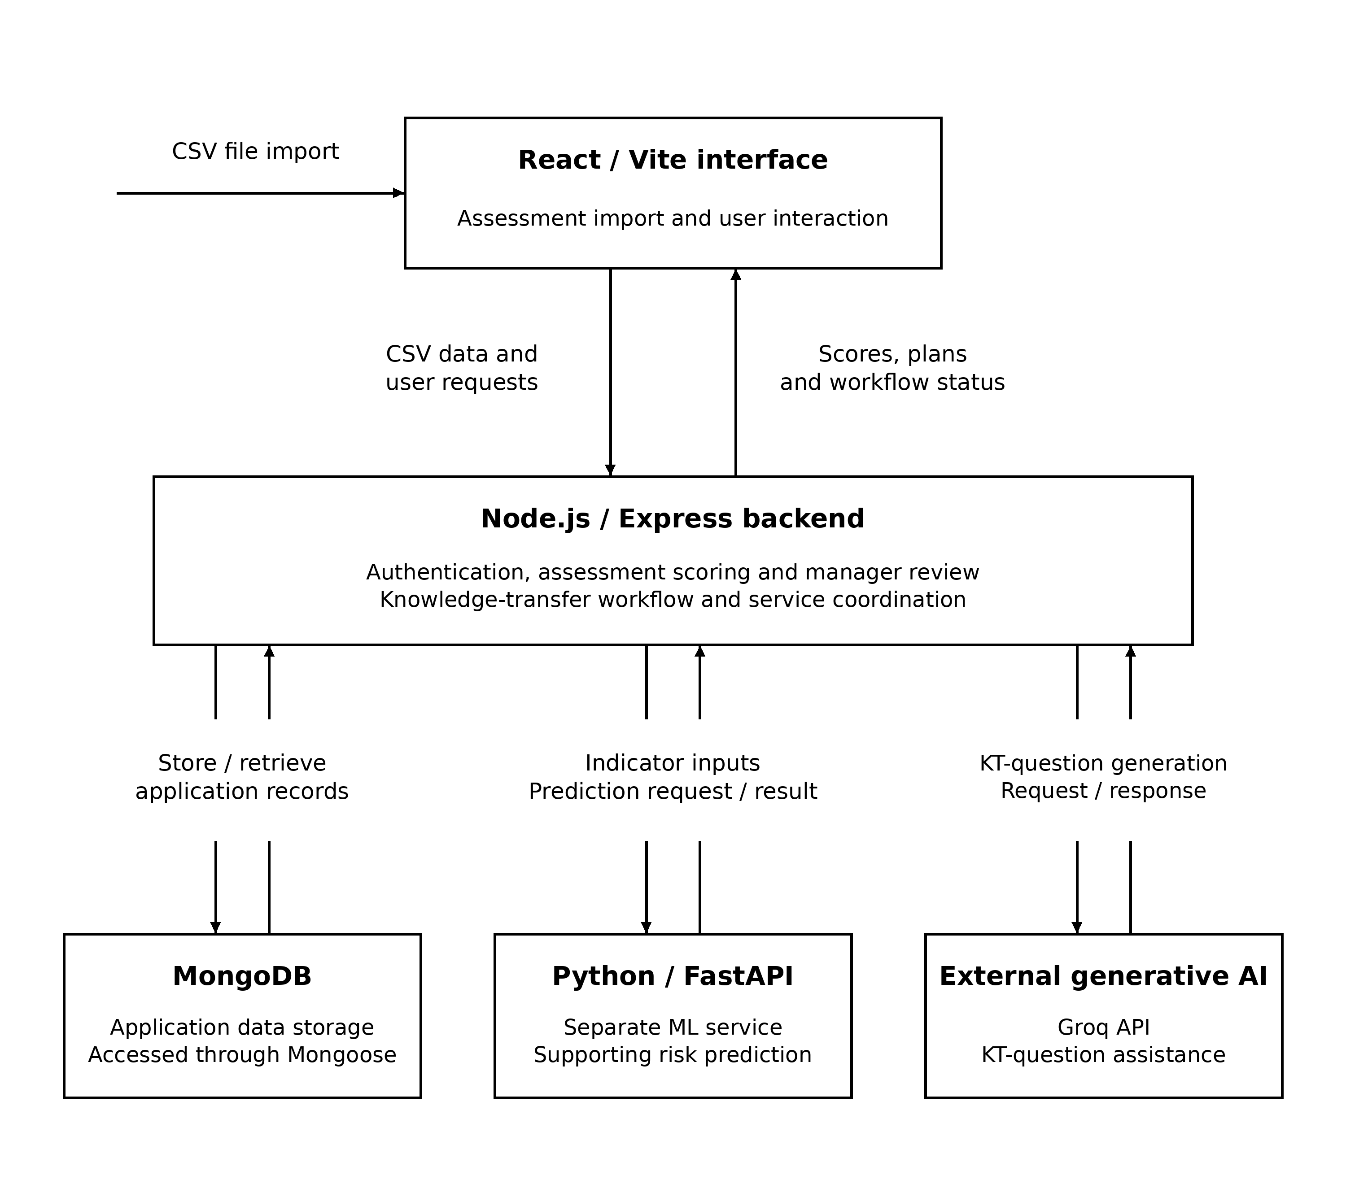
Figure 4.1: KnowledgeGuard architecture and principal data flows.

Figure 4.1 shows the separation between the user interface, application layer, data store, ML service, and generative-AI service. The Node.js/Express backend coordinates access to these components and keeps scoring, authorization, and KT workflow rules under application control. This architecture supports transparent risk processing while allowing the application to use fallback behaviour when an external supporting service is unavailable.

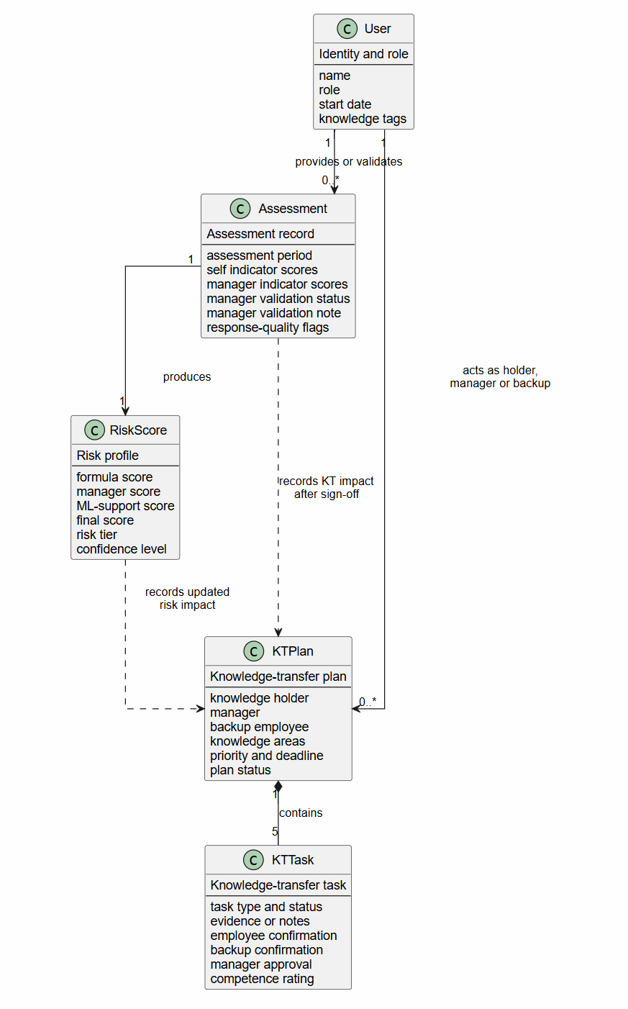
Figure 4.2: Class diagram and principal data relationships in KnowledgeGuard..
Figure 4.2 represents the principal records that provide traceability from assessment input to knowledge-transfer evidence. An assessment is associated with an employee and produces risk information that can be reviewed by a manager. An eligible employee may then be associated with a KT plan and its task records, which retain confirmations, evidence, competence review, and sign-off status. The diagram is a conceptual class/data-model view; it does not imply a relational database design or expose implementation-only fields.

Below Figure 4.3 identifies the responsibilities supported by KnowledgeGuard. Employees provide assessment information and complete assigned transfer activities. Managers review risk information, validate assessments, create and approve transfer plans, assess backup competence, and sign off completed plans. Backup employees participate in transfer activities and confirm sessions. HR users import authorised assessment data, view AHP consistency information, and export authorised evaluation data, while administrators manage users, roles, and AHP settings. The diagram therefore represents a role-based decision-support system, not an autonomous employment-decision system.

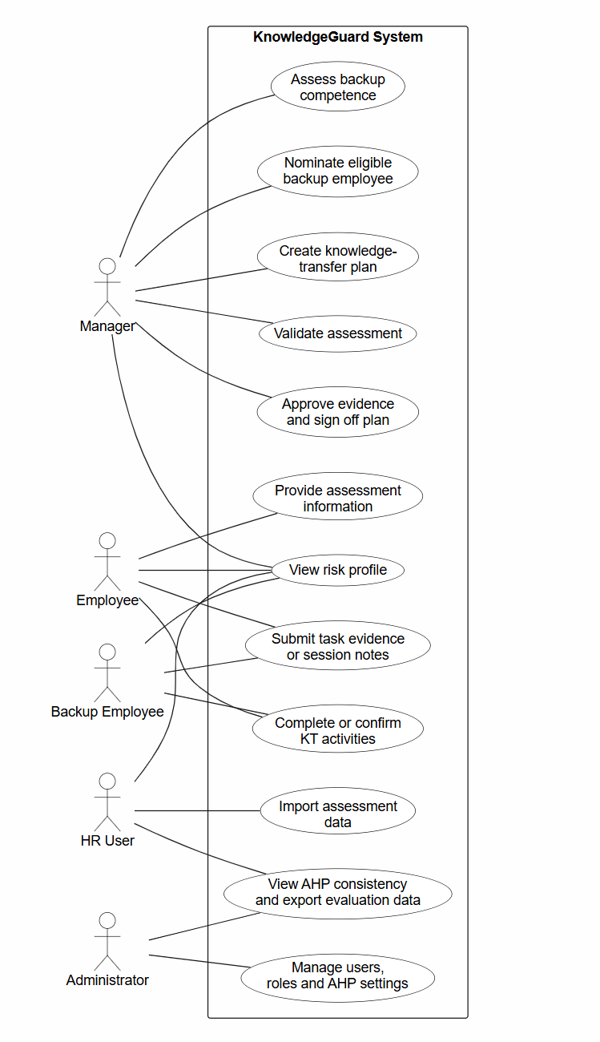
Figure 4.3: Use-case diagram for role-based KnowledgeGuard interactions.
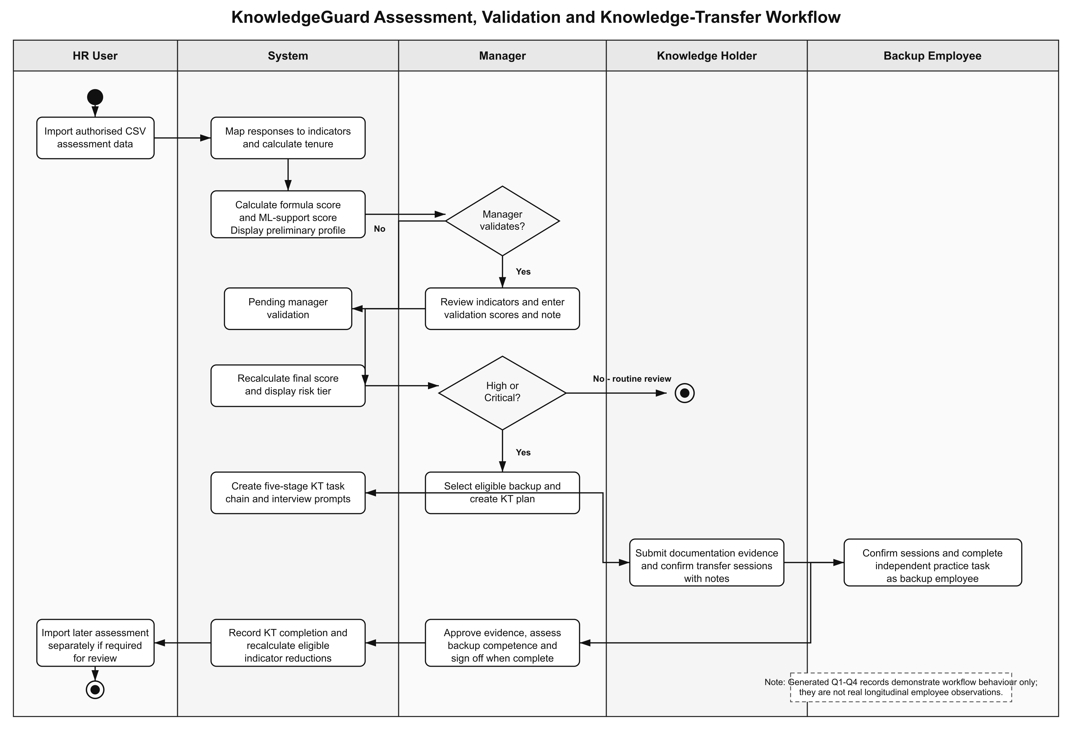
Figure 4.4: Activity diagram for assessment, validation and knowledge transfer.
Figure 4.4 shows the chronological workflow and separates human responsibilities from automated processing. It begins with assessment input and transparent scoring, then requires manager review before a high- or critical-risk case can proceed to knowledge-transfer planning. The diagram ends with manager sign-off, score recalculation, and the option to import a later assessment separately. This distinction prevents the workflow record from being represented as real longitudinal evidence.

4.4.2 From survey answer to indicator
The parser maps each recognized questionnaire option to a score, using a higher value for greater reported exposure, and groups the resulting values by indicator. The four survey-based indicators are expertise uniqueness (EU), documentation gap (DG), project criticality (PC), and collaboration dependency (CD). The fifth indicator, tenure (T), uses service-length bands calculated from the stored start date rather than the survey answer. The defined default formula is F = 0.25(EU) + 0.20(DG) + 0.20(PC) + 0.20(CD) + 0.15(T).
Table 4.4 records the meaning, source, and provisional weight of each component. These definitions describe assessment inputs rather than independent measures of a future loss event.
Table 4.4: KnowledgeGuard indicators and initial weights
Indicator | What the score represents | Source | Weight
EU | Few alternative holders of specialist work | Mapped employee survey | 0.25
DG | Inadequate documentation for essential tasks | Mapped employee survey | 0.20
PC | Consequences for important project work | Mapped employee survey | 0.20
CD | Other work depends on the holder | Mapped employee survey | 0.20
T | Service length according to stored start date | Calculated from personnel record | 0.15
The baseline weights are transparent researcher-defined prototype settings informed by literature, not estimated effects. Expertise uniqueness receives 0.25 because concentrated specialist knowledge is difficult to replace [9], [10]. Documentation gap, project criticality and collaboration dependency each receive 0.20 because they represent distinct exposures without evidence for a stronger ordering [1], [2], [11]. Tenure receives 0.15 as context rather than proof of irreplaceability. The percentages sum to 1.00. The later exploratory AHP group result differs from this baseline; it was reported, not applied, so all evaluated scores retain the predefined configuration.
For example, the Q1 question about how many colleagues can complete an employee’s complex deliverables contributes to expertise uniqueness. An answer indicating that nobody else can do so maps to a high indicator value; an answer indicating several capable colleagues maps to a lower value. Questions vary across the generated quarters, but the parser assigns the recognized answers to the same four indicator categories. This design enables a repeated assessment while changing the wording and work context of individual questions. The generated demonstration cannot by itself establish that the quarterly questionnaires measure these concepts equivalently in an organization.
For Q1-style responses, the parser examines variation across mapped items and checks direct against reverse-worded items. Fewer than four mapped responses do not trigger its standard-deviation check. Where the mapped scores have a standard deviation below 1.0, the system flags a straight-lining pattern and adjusts its confidence handling. A warning invites scrutiny; it is not a determination that an employee gave dishonest responses. The confidence discount is not directly subtracted from the numerical final score in the supplied scoring function.
The system offers AHP calibration of five indicator weights [20]. For raw form responses, the importer maps answers 1-9 to left/right ratios 9, 7, 5, 3, 1, 1/3, 1/5, 1/7 and 1/9, respectively; it then takes the geometric mean for each of ten named comparisons and forms a reciprocal 5 x 5 matrix. The component derives proposed weights from column-normalized row means, estimates lambda_max and calculates CI = (lambda_max - 5)/4 and CR = CI/1.12. The interface permits Apply only for CR < 0.10, and the API independently rejects CR at or above 0.10 without changing settings. A consistent proposal is not applied automatically. The study retained the baseline for scoring comparisons, and group consistency was not treated as predictive validation.

4.4.3 Combining the three scores
Table 4.5 makes the supporting machine-learning component explicit. The model supports, rather than replaces, the transparent formula and the manager's validation decision.

Table 4.5: Supporting machine-learning component
Element | Implemented choice | Evidence or output | Interpretation
Algorithm | Random Forest classifier: 100 trees, maximum depth 6, minimum split 5, balanced classes, seed 42 | RandomForestClassifier configuration | A non-linear supporting classifier, not an autonomous decision-maker
Inputs | EU, DG, PC, CD and tenure, each validated on a 1-10 scale | Prediction request validation | Uses the same indicators available to the formula
Default training data | 500 synthetic feature profiles labelled by the configured formula and tiers | Model metrics identify source as synthetic | No independent employee departure or retention outcome is predicted
Prediction | Tier probabilities mapped to fixed midpoints: low 1.5, medium 4.3, high 6.5, critical 8.8 | Probability-weighted supporting score | Produces a continuous ML support score alongside the tier
Internal evaluation | Five-fold stratified cross-validation when class counts permit | F1 = 0.8526 +/- 0.0487 on synthetic data | An internal rule-reproduction estimate, not field predictive validity
Explainability | Feature-importance values: EU .2849, DG .2101, PC .1799, CD .2463, tenure .0788 | Metrics endpoint | Synthetic-model association, not causal evidence
Resilience | Formula score substitutes when the ML service is unavailable | Backend scoring path | Risk assessment remains available without the ML service

Once an assessment is available, the backend computes F from employee-derived inputs. A manager-validated indicator set yields a separate manager formula score M. The FastAPI endpoint returns a supporting score L using a Random Forest classifier trained, by default, on 500 synthetic profiles labelled by the predefined formula [21]. Its class probabilities are converted to a numerical score using tier midpoints. After manager validation, the final score is R = 0.30F + 0.50M + 0.20L. Before validation, R = 0.70F + 0.30L. If the ML request fails, F substitutes for L, while a validated manager score still retains its 50% contribution. Numerical results are rounded and assigned low (up to 5.0), medium (above 5.0 to 7.5), high (above 7.5 to 9.0), or critical (above 9.0). These are prioritization tiers; they do not represent measured probabilities of departure.
The saved model evaluated here was trained on 500 synthetic profiles. Each label was a tier calculated from the baseline formula, so the classifier's measured performance shows how well it reproduces that configured rule. KnowledgeGuard can also retrain from real manager-validated assessment records: the route extracts the same five features, creates a label from the manager-scored formula, and ordinarily requires at least ten usable records from at least two tiers. This capability was not used for the reported model. Manager-derived labels remain assessment judgements; independent observed continuity outcomes would be needed to test prediction of actual knowledge loss.
Table 4.6: Configured operational risk tiers
Tier | Final score R | Workflow interpretation
Low | R ≤ 5.0 | Record assessment and review as needed
Medium | 5.0 < R ≤ 7.5 | Review exposure and supporting evidence
High | 7.5 < R ≤ 9.0 | Eligible holder for KT planning
Critical | R > 9.0 | Eligible holder for KT planning
A worked test case illustrates the arithmetic. With EU = 9, DG = 8, PC = 9, CD = 7, and T = 10, the default formula gives F = 0.25(9) + 0.20(8) + 0.20(9) + 0.20(7) + 0.15(10) = 8.55. The saved default model contains low, medium and high classes only, so its configured probability-weighted score cannot exceed the high-tier midpoint of 6.50. Using a manager score of 8.50 and the maximum currently possible ML score of 6.50 gives R = 0.30(8.55) + 0.50(8.50) + 0.20(6.50) = 8.115, rounded to 8.12 (high). This is an arithmetic demonstration using the current model's stated output boundary, not a captured organizational prediction. Chapter 5 reports the outputs actually supported by its demonstration evidence.
The Python service also offers Isolation Forest analysis of a supplied score history when at least three points are available [22]. This checks whether the latest score is unusual relative to the submitted series. It differs from the Node.js check for low-variation answers within one questionnaire, and it cannot identify why a score changed. Historical data in the present demonstration do not constitute longitudinal evidence from an organization.

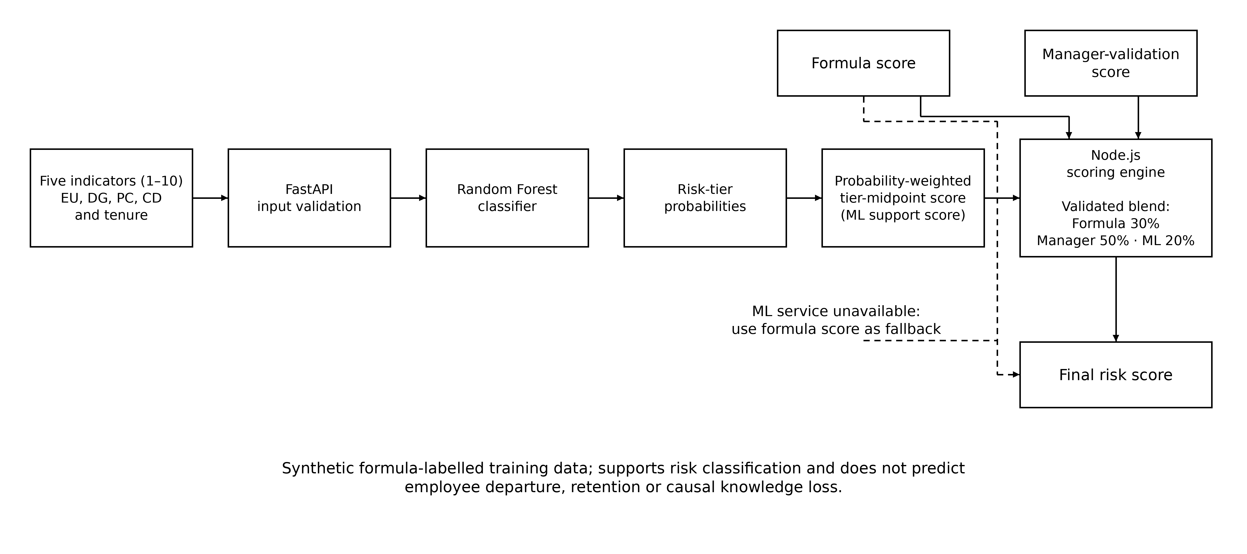
Figure 4.5: Supporting machine-learning score process in KnowledgeGuard.

Figure 4.5 makes the supporting role of machine learning visible. The Random Forest receives the same five indicator values used by the formula, returns tier probabilities, and produces a probability-weighted support score. The final scoring engine still uses the transparent formula and, after validation, manager judgement. The fallback path ensures that a risk assessment remains available if the ML service is unavailable.
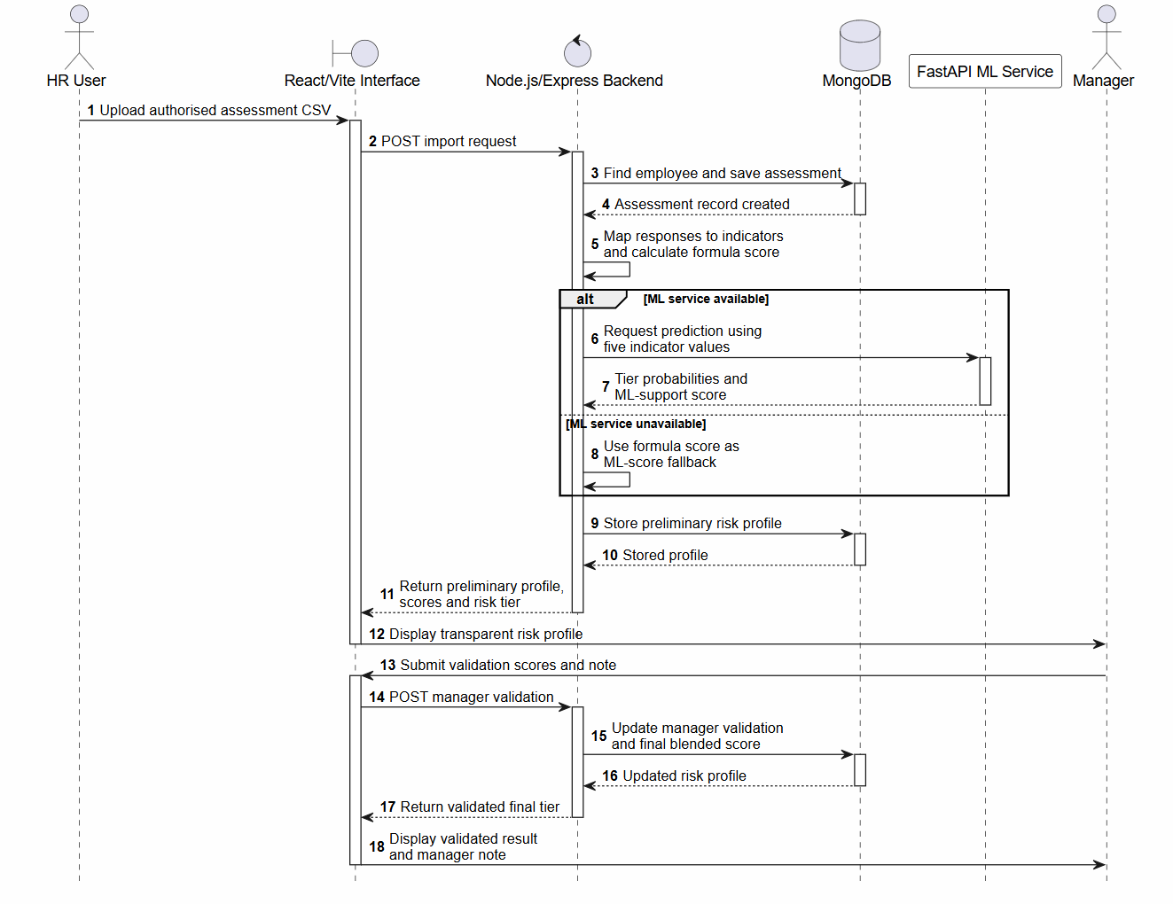
Figure 4.6: Sequence diagram for risk assessment and manager validation.
Figure 4.6 traces the messages used to create and validate a risk profile. The backend maps assessment responses, calculates the formula score, requests a supporting ML result, stores the profile, and returns transparent values to the interface. Manager validation then causes the backend to calculate and store the validated final score. The alternative path records the implemented formula fallback when the ML service cannot respond.

4.4.4 From risk review to knowledge transfer
For an eligible holder, the manager selects a backup, knowledge areas, priority and deadline. Tags pre-populate areas and rank candidates, but an eligible candidate without overlap can still be selected. The backend rejects a High or Critical backup. It requests AI interview questions and falls back to default questions if necessary. The plan creates five tasks: documentation, shadowing, structured interview, independent backup practice with competence rating, and sign-off. Participants confirm sessions; the manager reviews evidence. Sign-off requires prior tasks to be complete. Recorded completion does not establish lasting competence.
A manager-facing chat assistant can answer questions about the manager's active team using current risk summaries and propose a KT plan or validation change. The interface displays an action proposal and waits for the manager to select Execute or Validate. The backend still enforces role, holder and backup rules. In-app alerts notify users about risk-tier changes, assessments needing validation and KT task review. Email templates support risk alerts and reminders when Gmail credentials are configured; delivery was not measured in this study. These supporting functions were not separate outcomes in the SUS/TAM protocol.
The five stages have different evidentiary roles. Documentation links a usable resource; shadowing records observation and the participants’ confirmations; the structured interview records the expert’s responses to prompts; validation asks the backup to perform work independently and records a manager rating; sign-off confirms the preceding stages have been completed. Each stage is assigned a deadline. This sequence deliberately combines explicit material with opportunities to surface tacit practice [1], [4]. The record of approval is a procedural control; organizational effectiveness would require following the backup’s later work.
At sign-off, approved evidence can reduce DG by up to 3 points, EU by up to 3 according to backup competence, and CD by up to 2 when shadowing and interview requirements are met. Reductions apply to employee and available manager scores, with a floor of 1; PC and tenure do not change. The formula component can fall by at most 0.25(3) + 0.20(3) + 0.20(2) = 1.75 points before bounds. The final blended score can differ because manager and ML components are recalculated. Sign-off does not create a later-quarter assessment.
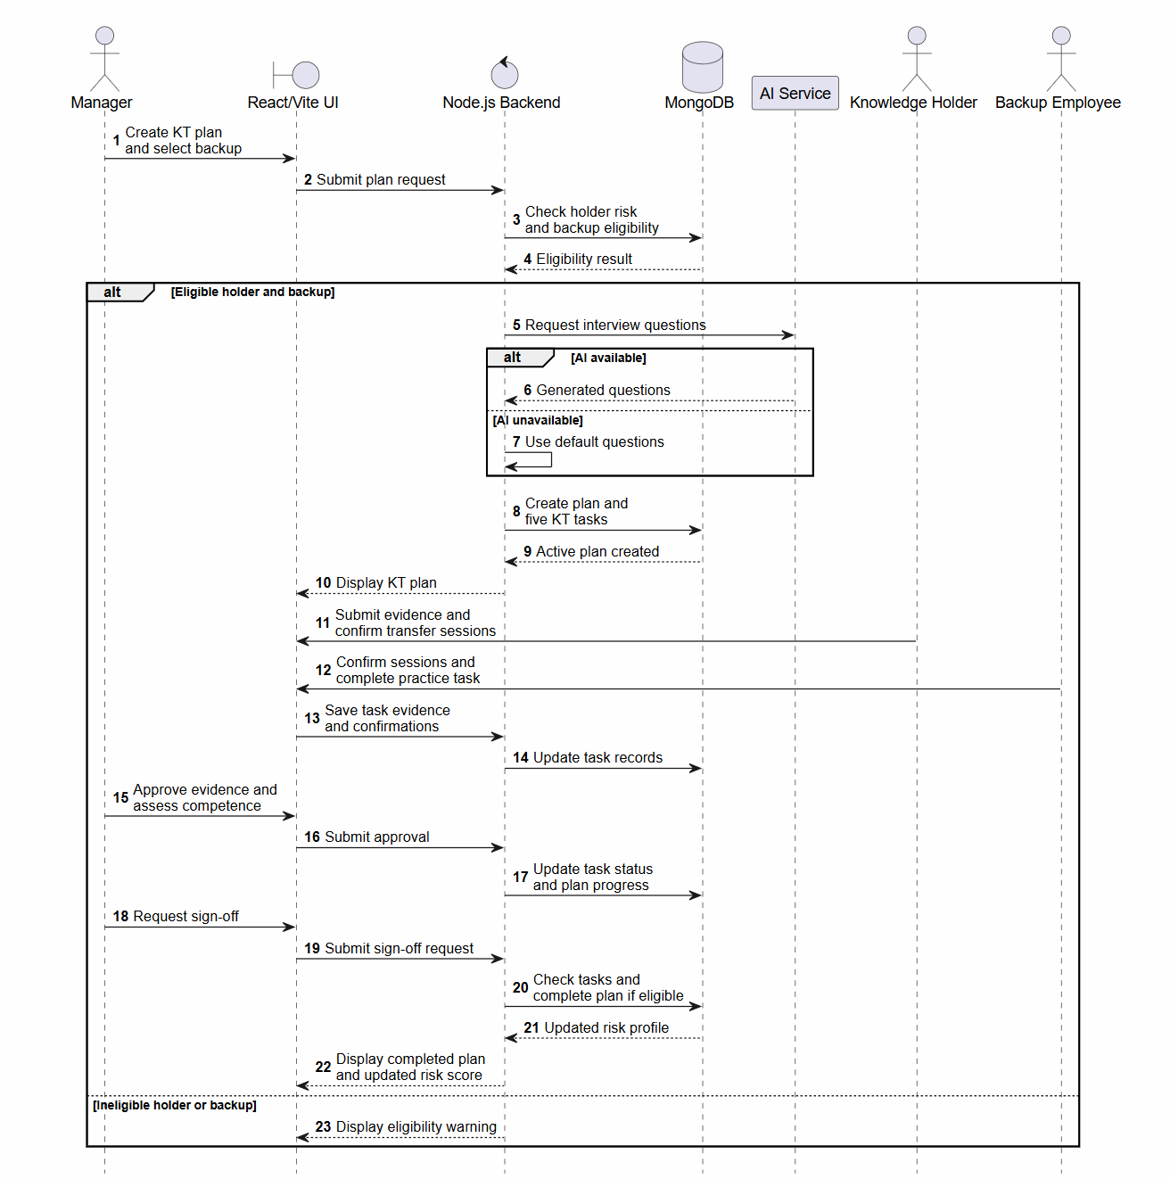
Figure 4.7: Sequence diagram for knowledge-transfer plan completion and sign-off.
Figure 4.7 shows how a validated high- or critical-risk case becomes a controlled transfer plan. The backend enforces holder and backup eligibility, records five task states, and checks prerequisites before sign-off. It also shows that AI-generated interview questions are optional: default questions are used if the external service is unavailable. The final score update reflects recorded workflow evidence and competence review, not proven long-term knowledge retention.

4.5 Development and implementation procedure
Development began with the questionnaire import and indicator mapping, then added transparent scoring and manager review. A separate Python service supplied classifier and history-anomaly functions. KT planning added eligibility, evidence, confirmations, competence review and sign-off. Manager chat and notifications were added as supporting ways to inspect and act on these records. The system stores scores and task states so a case can be followed across these steps.
Implementation decisions followed the project scope. Google Forms supplied questionnaire collection; the application consumed a CSV export rather than hosting a general survey builder. The risk formula and response checks remained in Node.js so that ordinary assessment processing did not require model inference. The Python service handled supporting ML output. Because the default classifier learns labels produced by the same formula used in the application, its output cannot be presented as independent predictive evidence. The generative service proposes interview questions, while participants supply the actual knowledge and a manager judges the backup’s performance.

4.6 Evaluation plan
Evaluation followed the four objectives. For O1, collected colleague responses were checked for indicator mapping, tenure-based scoring and quality warnings. Ten pairwise responses were converted and aggregated for an exploratory AHP comparison; the group's CR and proposed weights were reported separately from the baseline configuration. Controlled matrices tested whether an inconsistent proposal leaves stored settings unchanged. The generated Q1-Q4 records checked repeated import and score history without representing follow-up of the colleagues. Neither the exploratory AHP result nor the controlled safeguard changed the scoring weights used in the other demonstrations.
Table 4.7: Evaluation measures and evidence required
Aspect | Measure or observation | Evidence to present
Assessment processing | Mapped inputs, scores, warning state | De-identified test inputs and outputs
AHP configuration | CR safeguard for a submitted matrix | Configuration screen and implementation test; not baseline-weight validation
KT controls | Eligibility, task states, sign-off and scoreDelta | Test cases with expected and observed response
Usability | Aggregate SUS mean and sample SD | Aggregate calculation and n = 10
Acceptance | Mean usefulness, ease and intention ratings | Item-level scale and n for each construct

The four quarterly questionnaire sets are summarized in Table 4.8. They retain the same four survey-derived indicators while changing the work context and wording. This design supports repeated assessment without treating the generated quarterly records as a real longitudinal cohort.
Table 4.8: Quarterly assessment questionnaire design
Quarter | Questionnaire context | Common design
Q1 | Routine workflows and day-to-day dependency | Ten questions mapped to EU, DG, PC and CD; includes reverse-worded checks
Q2 | Crisis, absence and service continuity | Same indicators and response scale; different incident-based wording
Q3 | Architecture, technical change and release risk | Same indicators and response scale; different system-design wording
Q4 | Knowledge-transfer readiness and cross-training | Same indicators and response scale; different handover and shadowing wording

For O2, the literature review compares the assessment and KT design with knowledge-loss and decision-support research. Its outcome is the justified selection of indicators and a stated design gap rather than a numerical performance claim. For O3, functional scenarios examine manager validation, score blending, service fallback, high/critical KT eligibility, backup constraints, task evidence and confirmations, approval gates, and the sign-off recalculation. Each scenario should specify its starting record, input or action, expected result, and observed result. A short traceability table in Chapter 5 should map each objective to the evidence actually available; detailed individual test cases may be supplied in an appendix.
For O4, ten system-evaluation questionnaires are scored with the standard ten SUS items [24]. Odd-numbered items contribute response minus 1, even-numbered items contribute 5 minus response, and the summed contribution is multiplied by 2.5 to obtain an individual 0–100 score. The mean and sample standard deviation summarize the ten individual scores. Acceptance items are summarized separately as mean Likert responses for perceived usefulness, perceived ease of use, and behavioural intention, reflecting constructs related to the Technology Acceptance Model [25]. Descriptive summaries are appropriate for this small convenience evaluation; they do not justify population estimates or a claim that the system was adopted by an organization.
Before completing the questionnaire, evaluators received the deployed-system link and the Google Form link through WhatsApp. They used the prototype independently to log in, view the dashboard and an employee risk profile, review manager validation, review or create a KT plan, and view AHP validation. They then completed the SUS and acceptance items. The three acceptance constructs remain separate from SUS and from functional correctness. Reporting the number of returned questionnaires beside each mean lets the reader judge the descriptive scope. The evaluation did not include a commercial-platform comparison or a controlled task-time study.
A KT example reports scoreDelta as final score minus previous score. A later-quarter value requires a separate generated assessment import. These outputs verify workflow arithmetic, not reduced organizational disruption. The study had no independent departure or retention labels for predictive validation. Non-functional qualities are reported only where a corresponding check exists.

4.7 Ethics and project management
The study used standalone colleague responses and start dates for Q1 mapping, and separate generated Q1-Q4 records for workflow demonstration. Questionnaire results are reported in aggregate. Manager chat sends team names, identifiers, tags and risk summaries to the configured external AI provider; email templates can contain names and risk tiers. The demonstration used fictional identities. Real organizational deployment would require consent or another appropriate basis, data minimization, provider review and retention controls before these functions process employee information. Risk tiers support continuity preparation, not employment decisions.
The project used an iterative development workflow described as Agile-Kanban to coordinate implementation and refinement. This practice did not constitute a controlled experiment. The questionnaire files contain responses but do not document participant recruitment, consent, or institutional ethics approval. Those procedures must be checked against the researcher’s records before submission; no organizational deployment or formal ethics approval is claimed on the basis of the available evidence.

4.8 Chapter summary
The methodology connects a design science study to available test data, expert comparisons, application code, technical scenarios, and evaluator responses. It specifies the scoring and transfer procedures while setting limits on what the evidence can establish. Chapter 5 reports the corresponding artefact and evaluation results.

5. RESULTS

5.1 Chapter overview
This chapter reports the artefact and evidence available for KnowledgeGuard. Results are organized around the objectives and distinguish collected questionnaire responses from generated test records. The chapter describes observed values and implemented controls without claiming organizational knowledge-retention outcomes.

5.2 Final data and evaluation setting
The results draw on five distinct sources: 30 standalone colleague Q1 responses with manually supplied start dates for input mapping; 120 generated Q1-Q4 records for 30 fictional identities for workflow tests; ten deployed-prototype SUS/TAM evaluations; saved synthetic ML metrics; and ten pairwise responses for exploratory AHP analysis. Real colleague responses and generated identities were never joined. Online evaluator access was not a partner-organization field study. The AHP group result did not alter the baseline weights used for the system demonstrations.
Table 5.1: Final evaluation setting
Evidence source | Quantity | Permitted result
Standalone colleague assessment responses | 30 anonymised industry-colleague responses and manually supplied start dates | Response-to-indicator mapping, descriptive prototype input and tenure calculation
Separate generated Q1-Q4 test records | Controlled Q1-Q4 scenario sequence | Quarterly import, score-history and workflow demonstration only; separate from colleague responses
System-evaluation responses | 10 responses | Descriptive SUS and TAM findings
Saved ML evidence | metrics.json and model.joblib | Synthetic ML configuration and saved-model evidence only

5.3 Developed artefact and analytical outputs
The artefact connects CSV assessment import, transparent scores, manager validation, eligible KT planning, five transfer tasks, sign-off and score history. Knowledge tags suggest backups, while the backend blocks a high- or critical-risk backup. A supporting manager chat can explain team risk and propose a plan or validation for the manager to confirm. In-app alerts and conditionally configured email draw attention to pending risk and KT work. The chatbot and email functions are implementation features; the evaluation questionnaire did not isolate their usability or effectiveness.
[Insert Figure 5.1: synthetic preliminary risk profile before manager validation.]
Figure 5.1: Preliminary assessment of a synthetic demonstration record before manager validation, showing indicator-based formula scoring, supporting machine-learning output, and pending human review.
[Insert Figure 5.2: same synthetic profile after manager validation.]
Figure 5.2: Manager validation of the same synthetic demonstration assessment, showing recorded human review and the resulting validated risk classification.
[Insert Figure 5.3: synthetic KT plan creation and backup safeguards.]
Figure 5.3: Knowledge-transfer plan creation for a synthetic validated-risk case, showing knowledge-tag guidance and risk-based backup-selection safeguards.
[Insert Figure 5.4: five-stage KT task states.]
Figure 5.4: Five-stage knowledge-transfer workflow for a synthetic High- or Critical-risk demonstration case.
[Insert Figure 5.5: re-import the ten expert responses with the corrected raw-form importer; show CR 0.0822, proposed weights, and the unchanged baseline in Current Live Formula. Do not reuse the old CR 0.2000 screenshot as the expert result.]
Figure 5.5: Corrected AHP group result from ten pairwise responses, with proposed weights not applied to the live baseline.
[Insert Figure 5.6: generated Q1-Q4 score history.]
Figure 5.6: Quarterly score-history demonstration using a separate generated dataset; it does not represent real employee longitudinal observations.
The score arithmetic was checked against the implemented formula. For EU = 9, DG = 8, PC = 9, CD = 7 and T = 10, the formula score was 8.55. The saved default model contains low, medium and high classes only, so its configured probability-weighted score cannot exceed the high-tier midpoint of 6.50. Using manager score 8.50 and the maximum currently possible ML score of 6.50 gives a weighted final score of 8.12 and the tier high. This is an arithmetic demonstration of the current model boundary, not a captured organizational prediction. The configured boundaries in the current implementation are low at or below 5.0, medium above 5.0 to 7.5, high above 7.5 to 9.0, and critical above 9.0.

5.3.1 Simulated knowledge-transfer trace
Table 5.2 gives a transparent simulated trace of the implemented KT update. The example is not a real employee outcome and is included to demonstrate the code path. After documentation is approved, shadowing and interview are approved, and the backup is rated fully competent, the implementation reduces DG by 3, EU by 3 and CD by 2; PC and tenure remain unchanged. The post-sign-off formula score is therefore 6.80. In a live execution, manager and ML components are recalculated from the updated stored assessment and must be captured from the resulting system record; they are not inferred here. A later quarter is a separately imported assessment, not an automatic post-sign-off measurement.

Table 5.2: Simulated knowledge-transfer score trace
Stage | EU, DG, PC, CD, T | Formula component | Observed or derived system state | Evidence boundary
Before KT sign-off | 9, 8, 9, 7, 10 | 8.55 | Arithmetic worked case: formula 8.55; manager 8.50; ML 6.50 maximum; final 8.12, high | Arithmetic check using the implemented formula and blend
After approved documentation, shadowing, interview and fully competent validation | 6, 5, 9, 5, 10 | 6.80 | KT service applies EU -3, DG -3 and CD -2; manager and ML components are re-queried | Simulated code-path trace, not a real knowledge-retention result
Later assessment | Separately imported record from the Q1-Q4 test dataset | Calculated from that record | Creates a new score-history observation and delta | Generated demonstration data only

5.4 Core functional test results and implementation evidence
Table 5.3 records the principal functional checks for KnowledgeGuard. Results supported by interface screenshots, controlled test data or executed unit tests are identified separately from implementation inspection. An implementation-inspection result shows that the rule is present in the supplied code but is not presented as a live end-to-end test.

Table 5.3: Core functional test results and implementation evidence
Test ID | Functional requirement | Test action | Expected result | Actual result | Status
FT01 | Assessment import and mapping | Import valid authorised assessment CSV | Responses map to EU, DG, PC and CD; tenure is derived from Start Date. | The supplied standalone Q1 responses and separate generated Q1-Q4 records were mapped to the four survey-derived indicators. Tenure was calculated from the recorded start date. | Pass - controlled-data evidence
FT02 | Transparent scoring | Open a preliminary profile with known indicator values | Formula score and risk tier match the configured calculation. | The preliminary profile displayed five indicator values, the formula score, supporting ML score, preliminary final score and High-risk classification before manager validation. | Pass - Figure 5.1
FT03 | Manager validation | Submit manager validation values and a note | Validation is stored; final score and tier are recalculated. | The manager validation interface recorded validation status and a note, then displayed the recalculated final weighted score and risk classification. | Pass - Figure 5.2
FT04 | AHP consistency safeguard | Submit the reciprocal matrix used in the negative unit test, which produces CR = 0.2000. | Apply is disabled; the backend rejects an inconsistent matrix. | The interface showed the safeguard for this numeric input. Three unit tests covered consistent, inconsistent and invalid matrices. This input is not analysed as a valid result from the pairwise survey. | Pass - control demonstration and unit tests
FT05 | KT holder eligibility | Attempt KT-plan creation for a Low/Medium holder | Only a High/Critical holder can proceed to KT planning. | The KT-plan creation route checks the holder's latest tier and returns an error unless it is High or Critical. | Implementation inspection
FT06 | Backup safeguard | Attempt to select a High/Critical employee as backup | System prevents that employee from being selected as backup. | The client identifies High/Critical candidates and the backend independently rejects a backup whose latest tier is High or Critical. | Implementation inspection
FT07 | Five-stage KT plan | Create a plan for an eligible employee | Documentation, shadowing, interview, validation and sign-off tasks are created. | The active KT plan displayed the five required stages: documentation, shadowing, structured interview, backup competence validation and manager sign-off. | Pass - Figure 5.4
FT08 | Completion and mitigation control | Attempt early sign-off; then complete valid plan | Early sign-off is blocked; valid sign-off updates eligible indicators only. | The sign-off route checks that all non-sign-off tasks are complete before closure and applies the configured mitigation update only after valid sign-off. | Implementation inspection
FT09 | ML service fallback | Process assessment while ML service is unavailable | Formula fallback keeps the risk profile available. | The scoring engine substitutes the formula score when the ML prediction call returns no result, preserving a risk profile. | Implementation inspection
FT10 | Manager assistance | Inspect chat response and action proposal path | Manager confirmation is required before KT or validation API action | Chat interface contains explicit Execute and Validate buttons; backend routes enforce role and workflow rules. | Implementation inspection
FT11 | Notifications | Inspect risk and KT alert triggers and email path | Relevant in-app alert is created; email is attempted when configured | Alert service stores and pushes events; email service uses optional Gmail credentials. Delivery was not independently verified. | Implementation inspection

5.5 Evaluation results
After converting the form's left-equal-right responses to reciprocal AHP ratios and aggregating ten responses by geometric mean, the group matrix gave lambda_max = 5.3682 and CR = 0.0822. Because CR < 0.10, its proposed weights were eligible for optional application: EU 0.5177, DG 0.1272, PC 0.1478, CD 0.1505 and T 0.0567. The result describes the coherence of the aggregated matrix, not each respondent's consistency, predictive validity or universal priorities. The proposed weights differ substantially from the predefined baseline. They were not applied: all reported risk scores and KT demonstrations use EU 0.25, DG 0.20, PC 0.20, CD 0.20 and T 0.15. A separate controlled matrix with CR = 0.2000 demonstrates rejection of an inconsistent proposal; that value is not the expert-survey result.
Table 5.4: Baseline and exploratory AHP group weights for the five indicators.
Indicator | Predefined baseline | Proposed group AHP weight | Difference in percentage points
Expertise uniqueness (EU) | 25.00% | 51.77% | +26.77
Documentation gap (DG) | 20.00% | 12.72% | -7.28
Project criticality (PC) | 20.00% | 14.78% | -5.22
Collaboration dependency (CD) | 20.00% | 15.05% | -4.95
Tenure (T) | 15.00% | 5.67% | -9.33

For the ten evaluators, the mean SUS score was 89.50, the sample standard deviation was 3.07, and the range was 85.0 to 95.0. These aggregate values describe perceived usability in this small group; they are not a population estimate.
[Insert Figure 5.7: aggregate SUS chart showing mean 89.50, SD 3.07 and n = 10.]
Figure 5.7: Aggregate System Usability Scale result for ten evaluators.
TAM results showed mean perceived usefulness of 4.43, perceived ease of use of 4.53 and behavioural intention of 4.60 on five-point response scales. Behavioural intention was the highest of the three descriptive means. These figures indicate favourable evaluator responses but do not demonstrate organizational adoption.
Table 5.5: System-evaluation questionnaire summaries
Measure | n | Result | Interpretation boundary
SUS | 10 | Mean 89.50; SD 3.07 | Describes this evaluator group only
Perceived usefulness | 10 | Mean 4.43/5 | Not a population estimate
Perceived ease of use | 10 | Mean 4.53/5 | Not evidence of adoption
Behavioural intention | 10 | Mean 4.60/5 | Not evidence of actual use over time

[Insert Figure 5.8: TAM construct means, n = 10.]
Figure 5.8: Technology Acceptance Model construct means.
The saved ML model was trained on 500 synthetic, formula-labelled profiles. Its saved metrics report training accuracy 0.9780, weighted F1 0.9781, and mean stratified cross-validation F1 0.8526 (SD 0.0487). The model contains low, medium and high classes, but no critical class. These values measure reproduction of generated risk-tier labels, not predictive accuracy for real knowledge loss. The separate history-anomaly function needs at least three scores and was not validated against observed organizational events.
The real-data training route is implemented, but no real-data-trained model result is reported. Its labels come from manager-scored indicators, not independently observed knowledge-retention outcomes.
Table 5.6: Saved machine-learning metrics and interpretation
Metric | Value | Data basis | Permitted interpretation
Training accuracy | 0.9780 | 500 synthetic, formula-labelled profiles | Rule-reproduction performance only
Weighted F1 | 0.9781 | Same synthetic dataset | Not organizational predictive validity
Cross-validation F1 | 0.8526 +/- 0.0487 | Five-fold stratified validation | Internal estimate on synthetic labels
Class coverage | Low, medium and high only | Saved model metrics | Critical tier was not represented

5.6 Results by objective
Table 5.7 links each objective to the result available in this study. It avoids treating a design feature as proof of organizational impact.
Table 5.7: Results by objective
Objective | Observed result | Conclusion supported
O1 | Five indicators, mapped responses, quality flags and an AHP configuration safeguard were implemented | The assessment design can be demonstrated; baseline weights are transparent prototype settings, not population-validated weights
O2 | The literature review informed indicator, review and KT design choices | The design rationale is explicit and traceable
O3 | The artefact connects import, scoring, manager review, KT tasks and sign-off | The integrated workflow is implemented as a prototype
O4 | SUS and TAM summaries from ten evaluators are positive | The prototype received favourable descriptive feedback from this group

These sources answer different questions: collected-response mapping, generated workflow behaviour, exploratory AHP priorities, configuration safeguards, synthetic ML performance and descriptive evaluator feedback. None establishes actual organizational knowledge retention.

5.7 Chapter summary
KnowledgeGuard produced an assessment-to-transfer prototype with mapped input from 30 industry-colleague responses, a transparent predefined formula, an exploratory AHP group comparison and favourable descriptive SUS/TAM feedback from ten evaluators. The separate generated Q1-Q4 and synthetic ML data demonstrate behaviour, not outcomes after a real employee transition. Chapter 6 interprets these bounded findings.

6. DISCUSSION AND CONCLUSIONS

6.1 Discussion of key findings
The main finding is that KnowledgeGuard integrates activities that are often separate: structured assessment, transparent scoring, human validation, transfer planning and evidence review. This directly addresses the research question at the level of a prototype. Rather than treating a score as a decision about an employee, the system makes the score a prompt for manager review and possible continuity preparation. The 50% manager contribution after validation is important because survey-derived indicators cannot capture all workplace context.

6.1.1 Answers to the research questions
RQ1 is addressed by the operationalization of five literature-informed indicators in a structured assessment. The available evidence shows that the prototype can map assessment responses and a recorded start date to these indicators; it does not establish that the indicator set is universally valid.
RQ2 is addressed by the implemented scoring workflow. Formula scoring, manager validation and a supporting ML output are recorded separately before a final risk tier is presented. The result demonstrates integration and transparency, not independent prediction of employee departure or knowledge loss.
RQ3 is addressed by the implemented five-stage KT workflow. A high- or critical-risk holder can be linked to a backup, transfer activities, competence review and manager sign-off. The simulated trace demonstrates the workflow rule; it does not demonstrate sustained competence after a real transition.
RQ4 is addressed by functional and implementation evidence together with descriptive responses from ten evaluators. The SUS mean of 89.50 and TAM construct means above 4.4 indicate favourable feedback from this group, but do not establish organization-wide usability or adoption.
The baseline formula is a transparent, literature-informed prototype configuration, not a claim of optimal weights. The exploratory AHP group matrix was acceptably consistent (CR 0.0822) but placed much greater weight on expertise uniqueness (51.77% versus 25%) and less on tenure (5.67% versus 15%). This difference shows why organizational priorities and sensitivity to weights need further study. The proposed weights were not applied because the prototype evaluation used its predefined configuration throughout; post hoc adoption would change the reported risk classifications without outcome evidence or organizational approval. Consistency alone does not validate either set against actual knowledge-loss outcomes.
The ten evaluators gave favourable SUS and TAM responses. Their small, incompletely documented convenience group supports descriptive feedback only; it does not establish organization-wide adoption.

6.2 Comparison with literature
The design follows literature distinguishing explicit from tacit knowledge and showing that transfer requires more than storing documents [1], [2], [18]. Documentation, shadowing, interview and backup practice create different opportunities to pass on knowledge. The evaluation confirms the workflow can be recorded; it does not show that a backup performs effectively after an actual transition [19].
The choice to screen low-variation and contradictory questionnaire responses follows the principle that survey-quality indicators should trigger review rather than act as proof of dishonesty [17]. Likewise, the AHP consistency test follows Saaty’s method [20], but internal consistency is not external validation of indicator weights. The ML results reinforce this distinction: the classifier can reproduce formula-labelled synthetic profiles, but it has not been evaluated against independently observed knowledge-loss outcomes.

6.3 Contribution and practical implications
The study contributes an auditable design for connecting risk identification to action. The contribution is not a new universal five-factor scale or a predictor of resignation. It is the implemented workflow: indicators are visible; a manager can correct or contextualize a score; an eligible case receives a specific backup and tasks; and the system records evidence, confirmations, competence review and sign-off. This design may help an organization discuss where knowledge is concentrated before a transition creates disruption.
For practical use, the system should be positioned as decision support for continuity planning. It should not be used as a basis for disciplinary action, promotion decisions, redundancy selection or assertions about an employee’s likelihood of leaving. HR users should explain the purpose of the assessment, limit access by role, retain only necessary data and ensure human review of AI-generated interview questions.
The evidence supports an inspectable prototype from assessment to manager-reviewed transfer. Chat proposals and alerts can direct attention to records, but their effect on decisions or continuity was not evaluated separately. Organizational use would require local testing of the weights, data quality, privacy controls and backup performance after a transition.

6.4 Limitations
Several limitations affect the strength of the conclusions. First, the 30 standalone colleague responses are an anonymised convenience sample, while the separate Q1-Q4 dataset contains generated demonstration scenarios. Neither source can establish prevalence, a real longitudinal change, or the effect of KT on organizational disruption. Second, the ten system-evaluation responses are a small convenience group with incomplete documented recruitment and participant-role information. Third, the baseline weights are literature-informed prototype settings rather than empirically validated organizational parameters. The ML labels are generated from the formula and its saved training data lack the critical class. The reported metrics therefore cannot be described as predictive accuracy for knowledge loss.
Fourth, assessment acquisition relies on questionnaires and CSV import rather than live organizational integrations. Fifth, the exploratory AHP comparison used ten pairwise responses: its group CR does not establish each respondent's consistency, represent an organization, or validate weights against outcomes. Sensitivity and organizational review are still required before recalibration. Controlled matrix tests cover the consistency utility, but endpoint and operational testing remain. Sixth, chat sends team summaries to an external AI provider and email depends on configured credentials; neither received separate outcome testing. No penetration, load or privacy audit was completed. KT sign-off records workflow rules, not lasting backup competence.

6.5 Future work
Future work should begin with a consented organizational pilot collecting repeated assessments, manager reviews and independent evidence of backup performance after a transition. Real outcome labels would permit stronger ML evaluation. A documented stakeholder panel should repeat AHP with individual consistency checks, sensitivity analysis and formal approval before any live weight change. Endpoint-level AHP tests, role-based security and privacy review, load tests, and fuller user studies are also needed.
A further direction is privacy-preserving integration with organizational systems, subject to explicit permission, data-minimisation rules, access controls, retention limits and an impact assessment. An HRIS could provide role, start-date and approved skills information; a project-management platform such as Jira could provide issue ownership, workload concentration and project criticality metadata; source-control platforms such as GitHub or GitLab could provide repository ownership, review concentration and contribution continuity metadata; and approved documentation repositories could provide evidence of documented procedures. The system should use only the minimum necessary metadata. It should not collect authentication tokens, credentials, private messages, full source-code content, or personal data unrelated to knowledge continuity.
These integrations should support rather than replace structured assessment and manager review. Commit counts, ticket assignments, or document activity cannot reliably measure tacit expertise, quality of work, willingness to transfer knowledge, or a person's likelihood of leaving. Before any automated signal affects a risk score, future work should test its validity, potential bias, explainability and employee acceptance. A human manager should remain accountable for validation and for any knowledge-transfer decision.

6.6 Conclusions
KnowledgeGuard answers the research question by demonstrating how a decision-support prototype can connect employee-level knowledge-risk assessment with structured and manager-reviewed knowledge transfer. The system records five defined indicators, combines formula, manager and supporting ML information, and directs high- and critical-risk cases toward documented transfer tasks. Available evidence supports the operation of this prototype and favourable descriptive feedback from ten evaluators. It does not support a claim that the system predicts departures, validates universal weights or proves sustained organizational knowledge retention.

REFERENCES
[1] I. Nonaka, “A dynamic theory of organizational knowledge creation,” Organization Science, vol. 5, no. 1, pp. 14–37, 1994, doi: 10.1287/orsc.5.1.14.
[2] L. Argote and P. Ingram, “Knowledge transfer: A basis for competitive advantage in firms,” Organizational Behavior and Human Decision Processes, vol. 82, no. 1, pp. 150–169, 2000, doi: 10.1006/obhd.2000.2893.
[3] A. Daghfous, N. T. Amer, O. Belkhodja, L. C. Angell, and T. Zoubi, “Managing knowledge loss: A systematic literature review and future research directions,” Journal of Enterprise Information Management, vol. 36, no. 4, pp. 1008–1031, 2023, doi: 10.1108/JEIM-05-2022-0171.
[4] R. Iftikhar and M. Rashid, “Knowledge loss and retention in interorganizational projects: Evidence from public transportation projects from Pakistan,” International Journal of Managing Projects in Business, vol. 18, no. 2, pp. 241–264, 2025, doi: 10.1108/IJMPB-09-2024-0210.
[5] A. R. Hevner, S. T. March, J. Park, and S. Ram, “Design science in information systems research,” MIS Quarterly, vol. 28, no. 1, pp. 75–106, 2004, doi: 10.2307/25148625.
[6] M. S. Sumbal, A. Ključnikov, S. Durst, A. Ferraris, and L. Saeed, “Do you want to retain your relevant knowledge? The role of contextual factors in the banking sector,” Journal of Knowledge Management, vol. 27, no. 9, pp. 2414–2433, 2023, doi: 10.1108/JKM-02-2022-0128.
[7] S. Durst and M. Zieba, “Mapping knowledge risks: Towards a better understanding of knowledge management,” Knowledge Management Research & Practice, vol. 17, no. 1, pp. 1–13, 2019, doi: 10.1080/14778238.2018.1538603.
[8] M. S. Sumbal, E. Tsui, S. Durst, M. Shujahat, I. Irfan, and S. M. Ali, “A framework to retain the knowledge of departing knowledge workers in the manufacturing industry,” VINE Journal of Information and Knowledge Management Systems, vol. 50, no. 4, pp. 631–651, 2020, doi: 10.1108/VJIKMS-06-2019-0086.
[9] N. Galan, “Knowledge loss induced by organizational member turnover: A review of empirical literature, synthesis and future research directions (Part I),” The Learning Organization, vol. 30, no. 2, pp. 117–136, 2023, doi: 10.1108/TLO-09-2022-0107.
[10] N. Galan, “Knowledge loss induced by organizational member turnover: A review of empirical literature, synthesis and future research directions (Part II),” The Learning Organization, vol. 30, no. 2, pp. 137–161, 2023, doi: 10.1108/TLO-09-2022-0108.
[11] P. R. Massingham, “Measuring the impact of knowledge loss: A longitudinal study,” Journal of Knowledge Management, vol. 22, no. 4, pp. 721–758, 2018, doi: 10.1108/JKM-08-2016-0338.
[12] Microsoft, “Intro to file collaboration in Microsoft 365, powered by SharePoint,” Microsoft Learn, 2025. [Online]. Available: https://learn.microsoft.com/en-us/sharepoint/intro-to-file-collaboration. [Accessed: Sep. 24, 2026].
[13] Atlassian, “Use labels to organize content and attachments,” Confluence Cloud Support, n.d. [Online]. Available: https://support.atlassian.com/confluence-cloud/docs/use-labels-to-organize-your-content/. [Accessed: Sep. 24, 2026].
[14] ServiceNow, “Knowledge workflows,” ServiceNow Platform Documentation, Xanadu release, Aug. 1, 2024. [Online]. Available: https://www.servicenow.com/docs/r/xanadu/servicenow-platform/knowledge-management/r_KnowledgeWorkflows.html. [Accessed: Sep. 24, 2026].
[15] APQC, “APQC’s Knowledge Loss Risk Matrix,” Sep. 17, 2025. [Online]. Available: https://www.apqc.org/resource-library/resource-listing/apqcs-knowledge-loss-risk-matrix. [Accessed: Sep. 24, 2026].
[16] SAP, “SAP SuccessFactors Career and Talent Development,” 2026. [Online]. Available: https://www.sap.com/products/hcm/career-talent-development.html. [Accessed: Sep. 24, 2026].
[17] M. K. Ward and A. W. Meade, “Dealing with careless responding in survey data: Prevention, identification, and recommended best practices,” Annual Review of Psychology, vol. 74, pp. 577–596, 2023, doi: 10.1146/annurev-psych-040422-045007.
[18] E. Igoa-Iraola and F. Díez, “Procedures for transferring organizational knowledge during generational change: A systematic review,” Heliyon, vol. 10, no. 5, art. e27092, 2024, doi: 10.1016/j.heliyon.2024.e27092.
[19] M. Biron, K. Turgeman-Lupo, and O. Zaid-Dominik, “Contextualizing the usefulness of knowledge received from retiring employees: Leader behaviour and organisational culture,” Knowledge Management Research & Practice, vol. 22, no. 6, pp. 620–631, 2024, doi: 10.1080/14778238.2023.2297060.
[20] T. L. Saaty, “Decision making with the analytic hierarchy process,” International Journal of Services Sciences, vol. 1, no. 1, pp. 83–98, 2008, doi: 10.1504/IJSSCI.2008.017590.
[21] L. Breiman, “Random forests,” Machine Learning, vol. 45, no. 1, pp. 5–32, 2001, doi: 10.1023/A:1010933404324.
[22] F. T. Liu, K. M. Ting, and Z.-H. Zhou, “Isolation forest,” in Proceedings of the 2008 Eighth IEEE International Conference on Data Mining, Pisa, Italy, 2008, pp. 413–422, doi: 10.1109/ICDM.2008.17.
[23] Q. He and Z. Yang, “Generative AI-driven knowledge management in manufacturing firms: A five-stage framework for dynamic knowledge optimization and digital innovation,” Journal of Knowledge Management, vol. 30, no. 4, pp. 1447–1467, 2026, doi: 10.1108/JKM-03-2025-0418.
[24] J. Brooke, “SUS: A quick and dirty usability scale,” in Usability Evaluation in Industry, P. W. Jordan, B. Thomas, B. A. Weerdmeester, and I. L. McClelland, Eds. London, U.K.: Taylor & Francis, 1996, pp. 189–194.
[25] F. D. Davis, “Perceived usefulness, perceived ease of use, and user acceptance of information technology,” MIS Quarterly, vol. 13, no. 3, pp. 319–340, 1989, doi: 10.2307/249008.

APPENDICES

Appendix A: Assessment questionnaire and indicator mapping
This appendix records the Q1 standalone questionnaire used to collect anonymised colleague responses for prototype input demonstration. It contains no request for names, email addresses, employer names, project names or confidential work information. Start Date was collected only to calculate the tenure indicator. The separate Q2-Q4 records used in this study are generated workflow-test data; they are not further colleague questionnaires and are not presented as real employee observations.
Table A.1: Q1 assessment questions and score mapping
No. | Question and response options | KnowledgeGuard mapping
1 | How many other people can complete your complex deliverables without calling you? 3+; 1-2; Nobody. | EU: 2; 6; 10
2 | How steep is the learning curve for a capable colleague? <1 month; 1-3 months; >6 months. | EU: 2; 6; 10
3 | Are step-by-step standard operating procedures available and current? Fully; Partial or outdated; Unwritten. | DG: 2; 6; 10
4 | What percentage of your tasks could a colleague finish using available documentation? >80%; 40-79%; <40%. | DG: 2; 6; 10
5 | If key deliverables stall for 48 hours, what is the likely impact? Minor; Noticeable; Critical. | PC: 2; 6; 10
6 | How strongly is the work connected to service continuity, compliance, revenue or customer delivery? Low; Significant; Mission critical. | PC: 2; 6; 10
7 | How often do colleagues halt work while waiting for your knowledge or decision? Rarely; 2-3 times per week; Daily. | CD: 2; 6; 10
8 | How many colleagues or teams depend on your clearance, approval or specialist input? 1-2; 3-5; 6+. | CD: 2; 6; 10
9 | A peer in my department could step in and complete my complex deliverables. Strongly agree to strongly disagree. | EU reverse item: 2; 6; 10
10 | Troubleshooting procedures for my work are published, current and searchable. Strongly agree to strongly disagree. | DG reverse item: 2; 6; 10

Items 9 and 10 are reverse-worded consistency checks. A response-quality flag identifies low variation or contradictions for manager review; it does not label a participant dishonest. Tenure is not a questionnaire item: it is calculated from Start Date using the system tenure rule.

Appendix B: AHP response conversion and configuration evidence
KnowledgeGuard accepts a reciprocal 5 x 5 AHP matrix and calculates proposed weights, CI and CR. The ten available pairwise-response forms were reprocessed using the corrected direction: 1 favours the left indicator, 5 indicates equality and 9 favours the right. Form answers 1-9 map to left/right ratios 9, 7, 5, 3, 1, 1/3, 1/5, 1/7 and 1/9. Each pair was aggregated using the geometric mean of ten converted ratios. Table B.2 reports the resulting group matrix to four decimals; calculations used full precision. No respondent identifiers or timestamps are reproduced.
Table B.1: AHP configuration rule
Control | Input | Decision rule | System response | Evidence boundary | Study configuration
Matrix structure | Reciprocal 5 x 5 comparison matrix | Positive entries, reciprocal pairs, unit diagonal | Invalid matrices rejected | Implementation and unit-test evidence | Baseline unchanged
Consistency check | Controlled matrix supplied to the AHP component | CR < 0.10 before application | Inconsistent proposal cannot be applied | Functional safeguard only | Baseline unchanged
Authorized application | Consistent proposed weights | User must select Apply | Weights change only after authorization | No application performed in this evaluation | EU 0.25; DG 0.20; PC 0.20; CD 0.20; T 0.15

The corrected group matrix gave lambda_max = 5.3682 and CR = 0.0822; Table 5.4 reports its proposed weights. The result was inspected but not applied to live scoring. The evaluated baseline remained EU 0.25, DG 0.20, PC 0.20, CD 0.20 and T 0.15. The controlled inconsistent matrix used in FT04 is separate from these expert responses.
Table B.2: Aggregated reciprocal AHP comparison matrix (n = 10).
Indicator | EU | DG | PC | CD | T
EU | 1.0000 | 5.2962 | 4.4364 | 5.3437 | 4.0039
DG | 0.1888 | 1.0000 | 1.0000 | 0.9429 | 3.0852
PC | 0.2254 | 1.0000 | 1.0000 | 0.8737 | 4.6689
CD | 0.1871 | 1.0605 | 1.1445 | 1.0000 | 4.5530
T | 0.2498 | 0.3241 | 0.2142 | 0.2196 | 1.0000

Appendix C: System Usability Scale and Technology Acceptance Model instruments
The deployed-system link and evaluation Google Form were shared with ten working professionals through WhatsApp. They independently logged in, viewed the dashboard and an employee risk profile, reviewed manager validation, reviewed or created a KT plan, viewed AHP validation, and then completed the questionnaire. The available evaluation record does not contain evaluator names, organization affiliations, or exact role counts; it describes professional experience in HR, team management, technical work, or organizational processes.
Table C.1: Evaluator task protocol
Step | Evaluator task | Evidence purpose
1 | Log in to the deployed prototype using the provided access details. | Confirms access to the evaluated artefact.
2 | View the dashboard and one employee risk profile. | Assesses transparency and readability of risk information.
3 | Review manager validation information. | Assesses visibility of human oversight.
4 | Review or create a knowledge-transfer plan. | Assesses KT workflow understanding.
5 | View the AHP configuration screen. | Assesses visibility of the future calibration control.

The questionnaire contained the ten SUS items, three Perceived Usefulness items, three Perceived Ease of Use items and one Behavioural Intention item. The construct mapping was PU = questions 11-13, PEOU = questions 14-16 and BI = question 17. Report aggregate results only: SUS mean 89.50 and sample SD 3.07; PU 4.43; PEOU 4.53; BI 4.60 (n = 10). Exclude respondent identifiers and timestamps.

Appendix D: Functional test scenarios and evidence
The functional evidence in Table 5.3 is based on the supplied source implementation, generated CSV records and reproducible score calculations. It is not a production test log. The supporting ML metrics are retained in the project record `ml-service/metrics.json`, alongside `ml-service/model.joblib`; the saved record identifies synthetic training data, 500 profiles, the training timestamp, metric values, feature importances and class counts. The generated records, source files and any final redacted screenshots should be retained with the submission materials.
The following three short code-evidence listings support the core claims made in Chapters 4 and 5. Insert a readable source-code screenshot or a pasted, monospaced code excerpt for each listing. Limit each item to the relevant 8-18 lines, include the source-file path, and remove secrets, environment values, access tokens, database connection strings, names and email addresses. Do not attach login, registration or ordinary CRUD code.
Listing D.1: Formula score and validated final-score calculation
[INSERT SOURCE-CODE EVIDENCE: Capture the scoring function from the Node.js backend that calculates F = 0.25EU + 0.20DG + 0.20PC + 0.20CD + 0.15T and, where manager validation exists, calculates R = 0.30F + 0.50M + 0.20L. The capture must show the formula, manager contribution, ML contribution and formula fallback. State the actual source-file path beneath the screenshot.]
Explanation: This listing supports the transparent score arithmetic reported in Sections 4.4 and 5.3. It must not be used to claim that the score predicts resignation or measured knowledge loss.
Listing D.2: Knowledge-transfer sign-off and indicator update
[INSERT SOURCE-CODE EVIDENCE: Capture the backend sign-off or mitigation-update function showing that approved evidence and competence can reduce Documentation Gap, Expertise Uniqueness and Collaboration Dependency. Ensure the capture also shows that Project Criticality and Tenure remain unchanged, and that values are bounded within the configured scale. State the actual source-file path beneath the screenshot.]
Explanation: This listing supports the implemented workflow rule described in Sections 4.5 and 5.3. It demonstrates a system score update after recorded transfer evidence; it does not prove lasting knowledge retention.
Listing D.3: AHP consistency check in the interface
[INSERT SOURCE-CODE EVIDENCE: Capture the AHP interface component that shows CR and controls Apply, together with the backend route or shared utility that receives a reciprocal matrix, recalculates CR, and rejects a matrix where CR is greater than or equal to 0.10. Include the actual source-file paths beneath the screenshots.]
Explanation: This listing supports the client and server consistency controls reported in Sections 4.4 and 5.5. The unit tests demonstrate the calculation utility; an organizational deployment would still require endpoint-level and operational testing.
Listing D.4: Knowledge-tag backup recommendation and risk safeguard
[INSERT SOURCE-CODE EVIDENCE: Capture the KT-plan interface lines that compare the selected holder's knowledge tags with candidate tags and rank shared-tag candidates first. Capture the KT-plan backend route lines that reject a backup whose latest risk tier is high or critical. Include the actual source-file paths beneath the screenshots.]
Explanation: This listing supports the backup-selection workflow described in Sections 4.3, 4.4 and 5.3. Tag overlap recommends candidates but is not a mandatory proof that the chosen backup is competent; manager validation remains required.

Appendix E: System demonstration protocol and supplementary interface evidence
This appendix supports a reproducible viva demonstration. Use only seeded or generated demonstration records. The principal workflow screenshots belong in Figures 5.1 to 5.6; the material below provides additional supporting evidence rather than duplicating those figures.
Table E.1: Recommended live demonstration sequence
Order | Demonstration action | Point to explain
1 | Open the dashboard and select a synthetic High-risk employee. | Risk tier prioritises review; it is not an employment decision.
2 | Open the preliminary assessment before validation. | Five indicators, formula score and ML support are visible and explainable.
3 | Submit or show manager validation. | Manager review confirms or adjusts the assessment before KT planning.
4 | Create a KT plan and select a backup. | Knowledge tags guide candidates; High/Critical backups are blocked.
5 | Open the active KT plan and its five stages. | Completion is recorded as documentation, shadowing, interview, competence validation and sign-off.
6 | Show score history and AHP configuration. | Later quarters are separate generated imports; the AHP group proposal was not applied to the baseline.

[INSERT APPENDIX SCREENSHOT E.1: Redacted CSV-import or assessment-mapping result. Show recognized question mapping to EU, DG, PC and CD.]
[INSERT APPENDIX SCREENSHOT E.2: Redacted dashboard or risk-summary view using generated demonstration records.]
[INSERT APPENDIX SCREENSHOT E.3: Redacted backup competence-validation or final KT sign-off screen. Show only synthetic data.]
[INSERT APPENDIX SCREENSHOT E.4: Redacted post-sign-off risk-impact display. State that the display records limited configured mitigation, not measured lasting knowledge retention.]

Appendix F: Participant information consent and data handling
Include the final participant-information and consent text shown in the Q1 Google Form, the short recruitment message, and the data-handling statement. The material must state that participation is voluntary, that participants must not provide names, employer names, project names or confidential information, and that Start Date is collected only for tenure calculation. Include a withdrawal contact before anonymisation and the planned retention period.
Do not state that institutional ethics approval was received unless an approval letter is available. If an approval letter exists, insert it after the participant-information material and identify its reference number and approval date. If no letter exists, retain this appendix as participant-information and data-handling evidence only.

Appendix G: Reproducibility and evidence manifest
This appendix identifies the submission materials that support the thesis claims. It is an evidence index, not an invitation to disclose secrets. Remove environment files, connection strings, tokens, passwords and personal data from any submitted archive.
Table G.1: Submission evidence manifest
Evidence item | Location in project record | Purpose in thesis or viva
Q1 de-identified assessment CSV | Google Forms export after identifier removal | Real standalone response mapping and descriptive prototype input.
Generated Q1-Q4 test data | test_data directory or recorded import files | Quarterly workflow and score-history demonstration only.
AHP response conversion and group matrix | Corrected importer, ten-response export, Table B.2 and Figure 5.5 | Exploratory CR and proposed weights; baseline remains the evaluated configuration.
System-evaluation response CSV | KnowledgeGuard System Evaluation response export | SUS and TAM aggregate calculations.
ML evidence | ml-service/metrics.json and model.joblib | Synthetic training configuration, metrics and saved model record.
Source-code and screenshot evidence | Appendices D and E | Traceability for formula, safeguards, workflow and demonstration.

